Lesson: How to Graph Vertical and Horizontal Lines
Show how to graph $y=3$
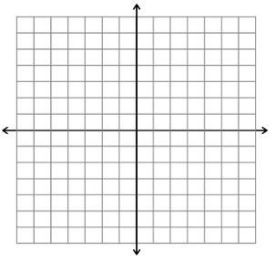
Show how to graph $x=-2$
How do you know if you are working with a vertical line? How do you graph it?

How do you know if you are working with a horizontal line? How do you graph it?

Examples Graph the following:
a. $x=4$

b. $y=-1$

