Lesson: The Slope of a Line
What does slope represent?

Draw the various possible slopes of lines:

How do find the slope of a line?

Examples Find the slope of the following lines:
a.  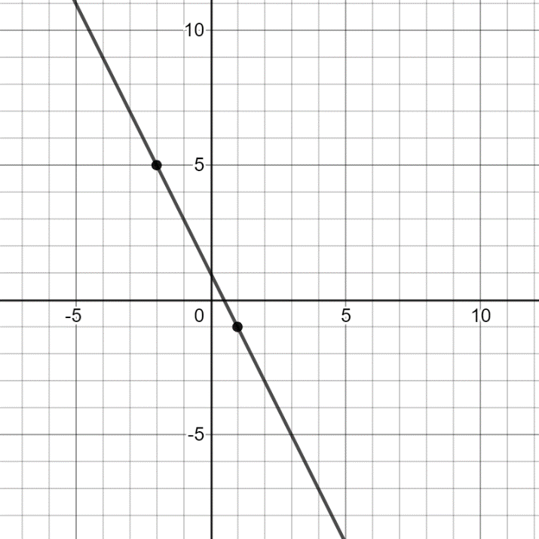 | b.  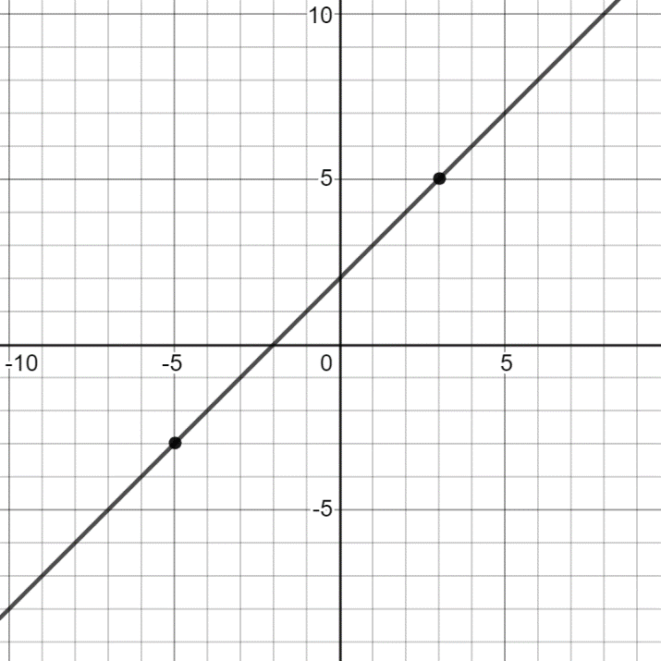

What is the slope formula?

Examples Use the slope formula to find the slope between the pairs of points:
a. $(3, 5)$ and $(4, 8)$ | c. $(7, 2)$ and $(7, 4)$
b. $(6, -2)$ and $(-2, 4)$ | d. $(2, 4)$ and $(-1, 4)$

