Examples: Position, Velocity, and Acceleration from a Graph
This is the graph of velocity for an object. The y-axis is m/s, the x-axis is seconds; the graph is from desmos.com. I have reprinted the graph for each question is case you want to mark it up.
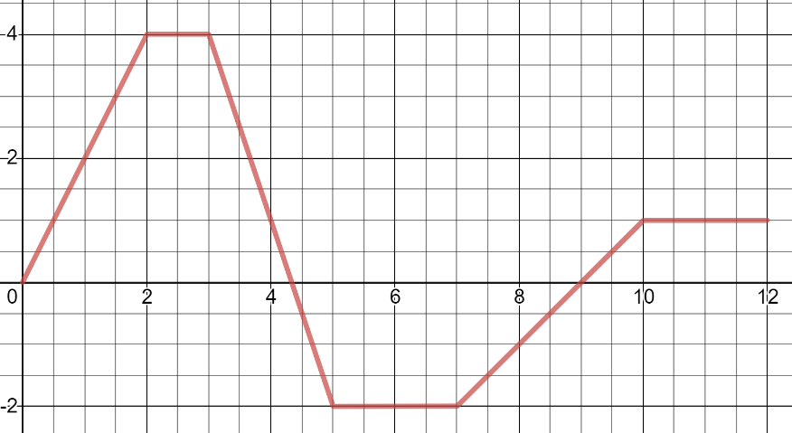
When does the object reverse its direction?

When is the object going a constant speed?

What would the graph of the object’s speed look like?

What would the graph of the object’s acceleration look like?

When is the object’s acceleration …
Positive?

Negative?

Constant?

When does the object attain its greatest speed?

