Lesson: Sigma Notation with Riemann Sums
Our goal in this lesson is to figure out how to use Riemann Sums with Sigma Notation. To get you warmed up for this idea, we will practice figuring out how to write certain Riemann sums:
Examples Write the following sums using sigma notation.
a. $1+2+3+4+5$

b. $2+4+6+8+10+12$

c. $1-3+5-7$

Previously we had discussed how to computer Riemann sums. Using $f\left(x\right)=4-x^{2}$ on $\left[0, 2\right]$, create 4 partitions and write out how to calculate the sum using right-hand endpoints. Can you figure out how to write this sum as a Riemann sum?
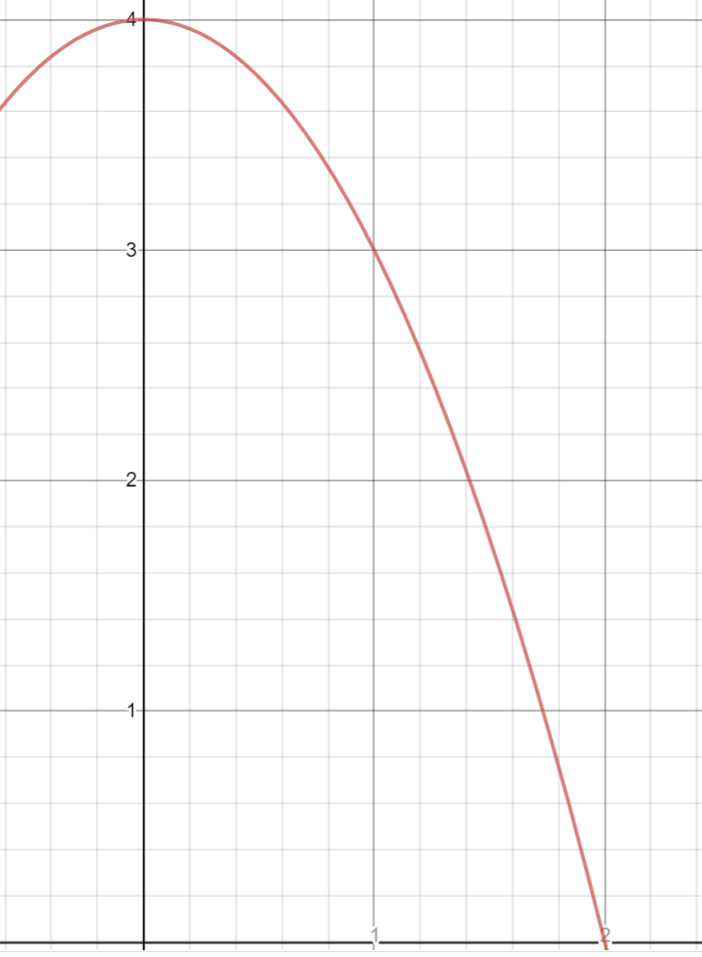

We will continue the pattern. Continuing to use $f\left(x\right)=4-x^{2}$ on $\left[0, 2\right]$, create 8 partitions and write out how to calculate the sum using right-hand endpoints. Can you figure out how to write this sum as a Riemann sum?
Can you determine how you might generalize this for n subintervals?

Write out the Riemann sum formula for using right-hand endpoints:

How can we manipulate this formula so that we use left-hand endpoints instead? Write this down:

Example Use the right-endpoint Riemann sum formula to calculate a formula for determining the sum for n equal subintervals for $f\left(x\right)=x^{2}+1$ on $\left[0,2\right].$

We have already determined that the best Riemann sum would have an infinite amount of subintervals. What happens if you evaluate your formula as $n→∞?$ Draw an illustration of what this represents.

