Lesson: Equations of Circles and How to Graph Circles
Draw the circle in the video and label the relevant parts of it.

Using your sketch above, explain how the distance formula can be used to help us determine the equation of a circle (you will need to summarize the explanation in your own words).

What is the Center-Radius Form of the equation of a circle?

Example Find the center radius form of a circle using the given information.
a. center $(-2, 3)$ and radius 4

b. center $(0, -1)$ and radius 2

Example Graph the following circles.
a. ${\left(x-1\right)}^{2}+{\left(y+3\right)}^{2}=4$  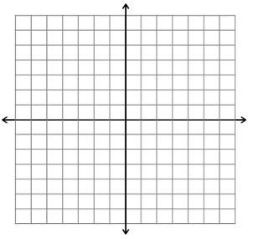 | b. $x^{2}+y^{2}=9$

Expand ${\left(x-1\right)}^{2}+{\left(y+3\right)}^{2}=4$ and show how this creates the general form.

What is the General Form of the equation of a circle?

Example Review how to use completing the square with the equation: $x^{2}-6x+4=0$.

Example Show how to use completing the square to write each in the center-radius form, and then sketch a graph of the circle.
a. $x^{2}-4x+y^{2}+8y-44=0$

b. $x^{2}+y^{2}+2x-6y+14=0$

