Lesson: Review of Functions
How do you represent a function?

What is a function often interchangeable with? How can you rewrite $f\left(x\right)=3x+8$?

So what IS a function? What does it actually represent?

What’s another handy feature of functions?

What are the domain and range?

Does domain and range only work for functions?

Examples Are the following functions, and what is the domain and range?
a. $\left\{\left(2,3\right), \left(5, -1\right), \left(-3, 7\right)\right\}$

b. $\left\{\left(-1, 5\right), \left(-8, 3\right), \left(-1, 6\right)\right\}$

What is the Vertical Line Test, and how does it help you determine if you have a function?

Example State the domain and range of the following, and use the vertical line test to determine if the graph represents a function.
a.
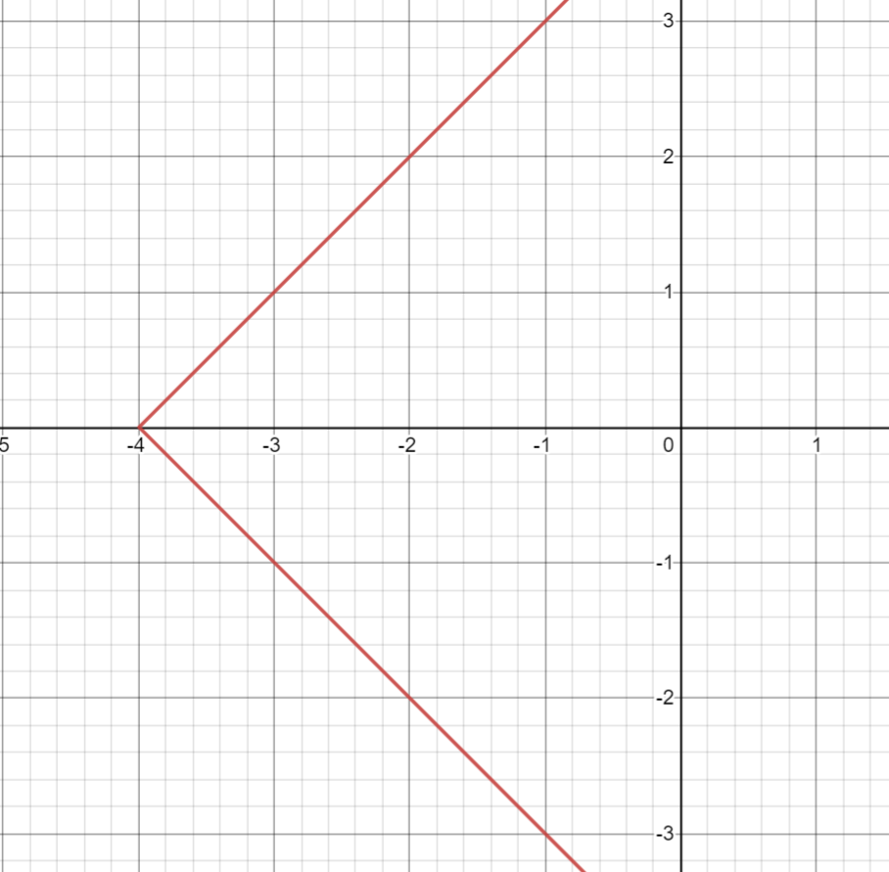

b.
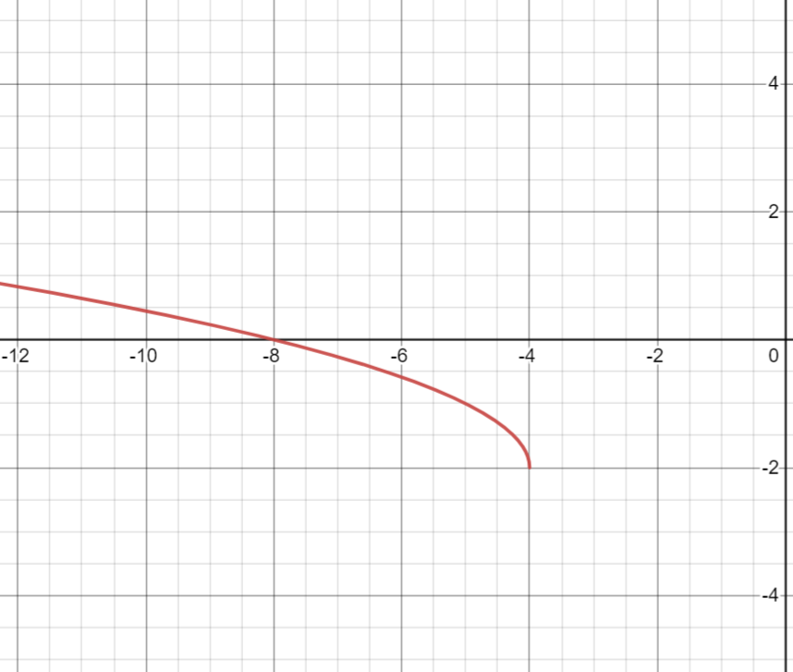
Examples Determine if the following represent functions.
a. $y=3x^{2}$

b. $x=y^{2}$

c. $y=\frac{5}{x^{2}}$
Example Write the following in function notation: $3x+2y=6$

Example Suppose $f\left(x\right)=3x-5$ and $g\left(x\right)=x^{2}+4x-1$ and $h\left(x\right)=\left\{\left(2, 5\right), \left(6, -3\right), \left(-1, -4\right)\right\}$. Find the following:
a. $f\left(7\right)=$

b. $g\left(3\right)=$

c. $f\left(k\right)=$

d. $g\left(x+h\right)=$

e. $h\left(6\right)=$

