Lesson: The Basic Graphs of Rational Functions
A rational function is a function of the form:
$\frac{f\left(x\right)}{g\left(x\right)}$, $g\left(x\right)≠0$
Where $f(x)$ and $g(x)$ are polynomials.
There are 2 graphs that we view as the most basic version of rational functions.
Make a table and graph $f\left(x\right)=\frac{1}{x}$
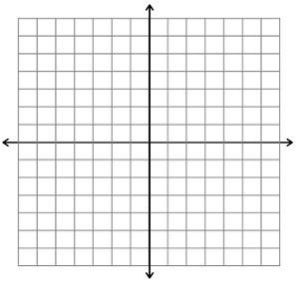
What is the domain and range?

Where does the graph not exist (ie where is it discontinuous)

What are the y-axis and x-axis for this graph?

What kind of symmetry does this graph have?

Make a table and graph $f\left(x\right)=\frac{1}{x^{2}}$
What is the domain and range?

Where does the graph not exist (ie where is it discontinuous)

What are the y-axis and x-axis for this graph?

What kind of symmetry does this graph have?

Example Describe the translations for the following graphs, and then draw an approximate sketch of the graph.
a. $f\left(x\right)=\frac{1}{{\left(x+1\right)}^{2}}-2$

b. $g\left(x\right)=-\frac{2}{x}+1$

Sketch what happens for odd powers of n for: $f\left(x\right)=\frac{1}{x^{n}},$ ie just draw a sketch of $y=\frac{1}{x^{3}}, y=\frac{1}{x^{5}}, y=\frac{1}{x^{7}}$

Sketch what happens for higher even powers of n for: $f\left(x\right)=\frac{1}{x^{n}},$ ie just draw a sketch of $y=\frac{1}{x^{4}}, y=\frac{1}{x^{6}}, y=\frac{1}{x^{8}}$

