Lesson: A Review of Exponential Functions and their Graphs
What is the form of a general exponential equation?

Example Let $f\left(x\right)=3^{x}$and $g\left(x\right)={\left(\frac{1}{2}\right)}^{x}.$ Find the following.
a. $f(-2)$

b. $f\left(\frac{3}{2}\right)$

c. $g(-3)$

d. $g(3.2)$

Sketch the graph of $f\left(x\right)=2^{x}$ and create a table to go with it.
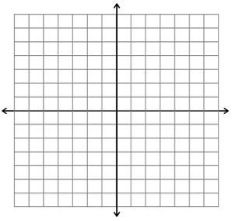
When will an exponential function $f\left(x\right)=a^{x}$ take this shape?

What is the x-axis for this graph?

What are 3 standard points to note here?

What is the domain and range?

Sketch the graph of $f\left(x\right)={\left(\frac{1}{2}\right)}^{x}$ and create a table to go with it.
When will an exponential function $f\left(x\right)=a^{x}$ take this shape?

What is the x-axis for this graph?

What are 3 standard points to note here?

What is the domain and range?

Examples Describe the translations and sketch the following graphs.
a. $f\left(x\right)=-3^{x}+1$

b. $f\left(x\right)={\left(\frac{1}{2}\right)}^{x+1}-2$

