Lesson: The Unit Circle and Circular Functions
Explain how we create the unit circle:

What is the equation for the unit circle?

Recall the formula for arc length is $s=rθ.$ When the radius of the circle is 1, what does this formula become?

Why does this matter / what is cool about this?

Since r=1 on the unit circle, what can we say about our previously studied trig functions? Just summarize what we discussed in the video as best as you can.

Write out the circular functions
1. | 4.
2. | 5.
3. | 6.

Explain the symmetry of the unit circle:

If a point $(a, b)$ in on the unit circle, what other points are guaranteed to be on the unit circle?

How can we use symmetry with drawing the unit circle? How is it handy?

Label the unit circle. Note: you will have to have this memorized! These are the standard angle measures that you’d be expected to do without a calculator!
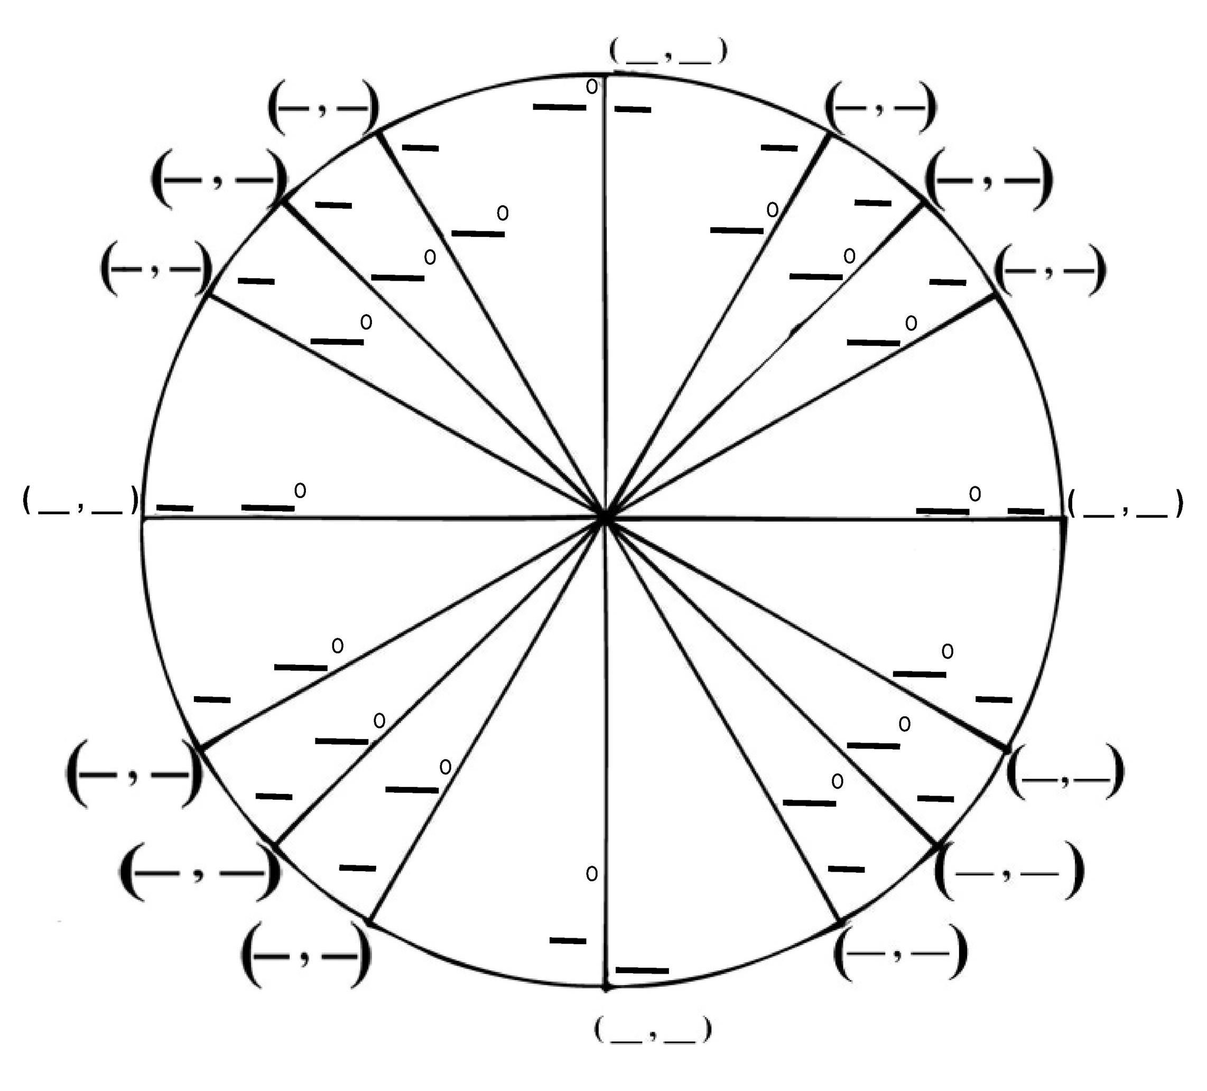
Now, going back to the circular functions we discussed, how do you view the x-coordinates?

How do you view the y-coordinates?

Examples Use the unit circle to find the values of the following:
a. $\sin{\frac{π}{3}}$

b. $\cos{\frac{5π}{4}}$

c. $\sin{\frac{11π}{6}}$

