Lesson: Determining the Equations of Tangent and Cotangent from Graphs
Graphs from desmos.com of course!
a.
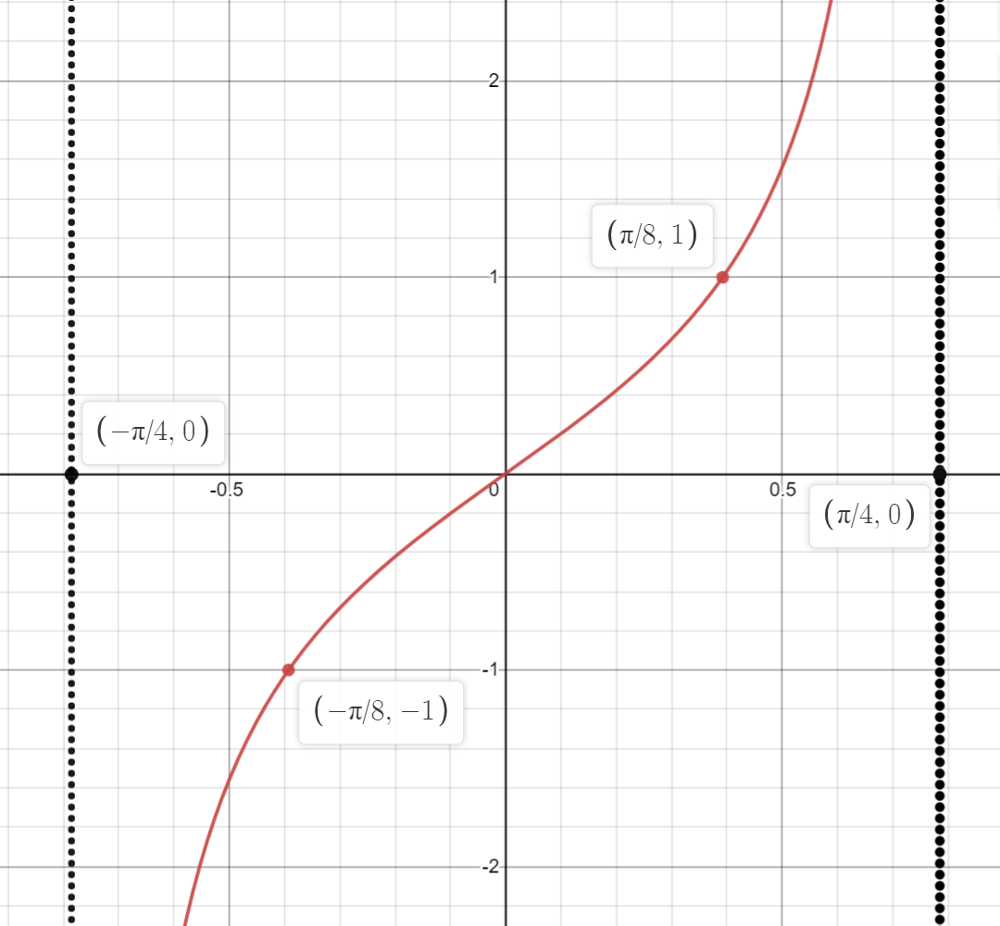

b.
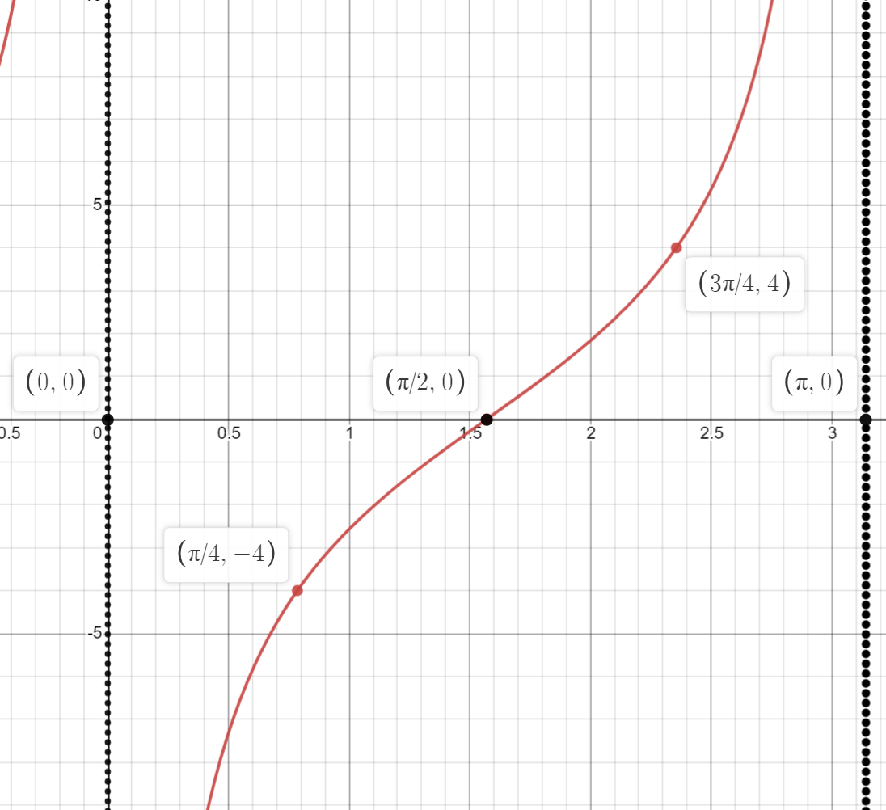

c.
