A Review of Lines
Part 2: Slopes, Vertical and Horizontal Lines, and Equations of Lines
Now we will discuss other ways to find slope.
Show how to find the slope from the graph of the lines. (Graphs are from desmos.com)
a.  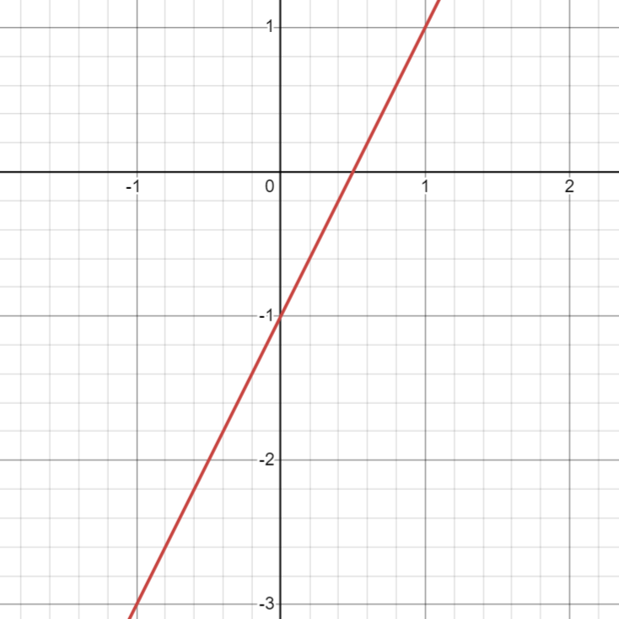 | b.  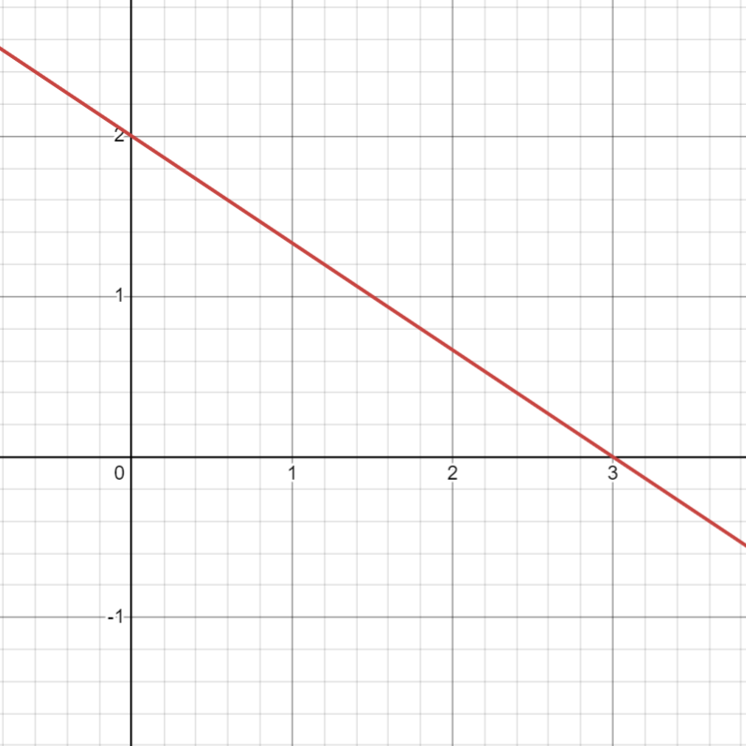

There is also a formula to find the slope between 2 points. What is the formula?

Find the slope between the following sets of points:
a. $(4, 5)$ and $(2, 7)$

b. $(-1, 3)$ and $(-4, 7)$

c. $(4, 5)$ and $(4, 7)$

d. $\left(3, 6\right)$ and $(5, 6)$

What is the equation format for any vertical line? How can you remember this?

What slope does every vertical line have?

What is the equation format for any horizontal line? How can you remember that?

What slope does every horizontal line have?

Lastly, we need to discuss how to write the equation of lines.
To warm up this skill, write the equation of a line that goes through the point $(4, 5)$ and has slope $m=-2.$ Put your final answer in slope-intercept form AND also standard form.

Write the equation of a line that goes through the point $(-2, 3)$ and has slope $m=-\frac{1}{2}.$ Put your final answer in slope-intercept form.

Write the equation of a line that goes through the points $(2,3)$ and $\left(3, 5\right).$

Write the equation of a line that goes through the points $(-2, -3)$ and $\left(-4, 5\right).$

