A Review of Lines– More Practice on Slope
Determine the slope of the line from the graph. (Graphs from desmos.com)
a.  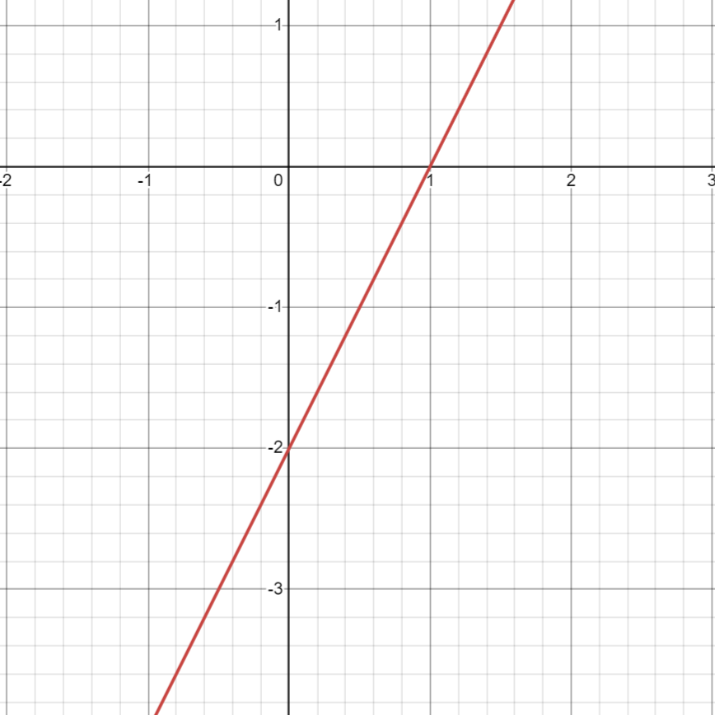 | d.  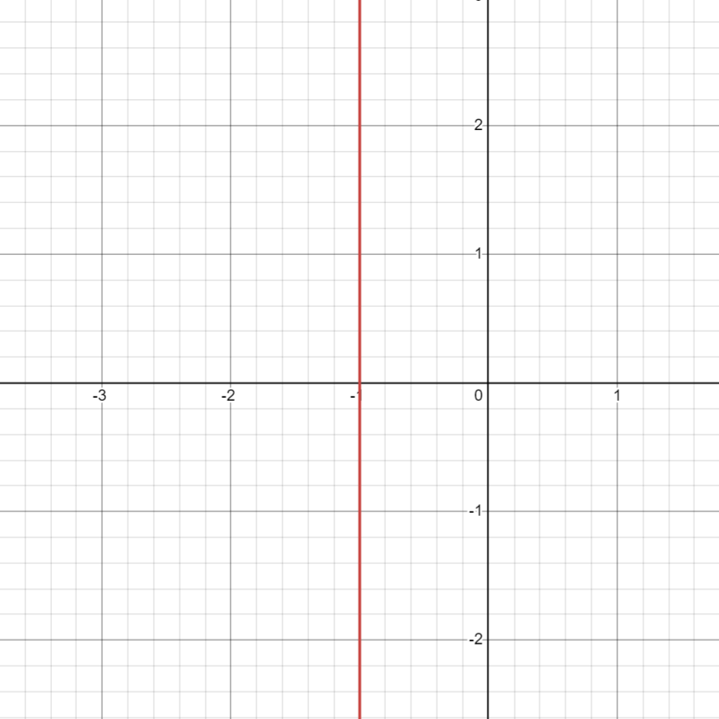
b.  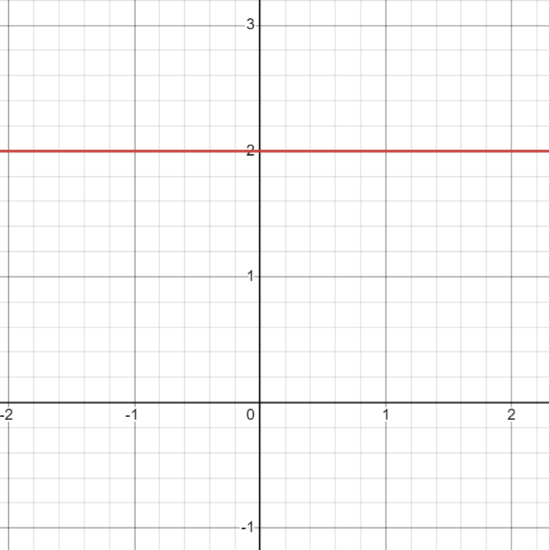 | e.  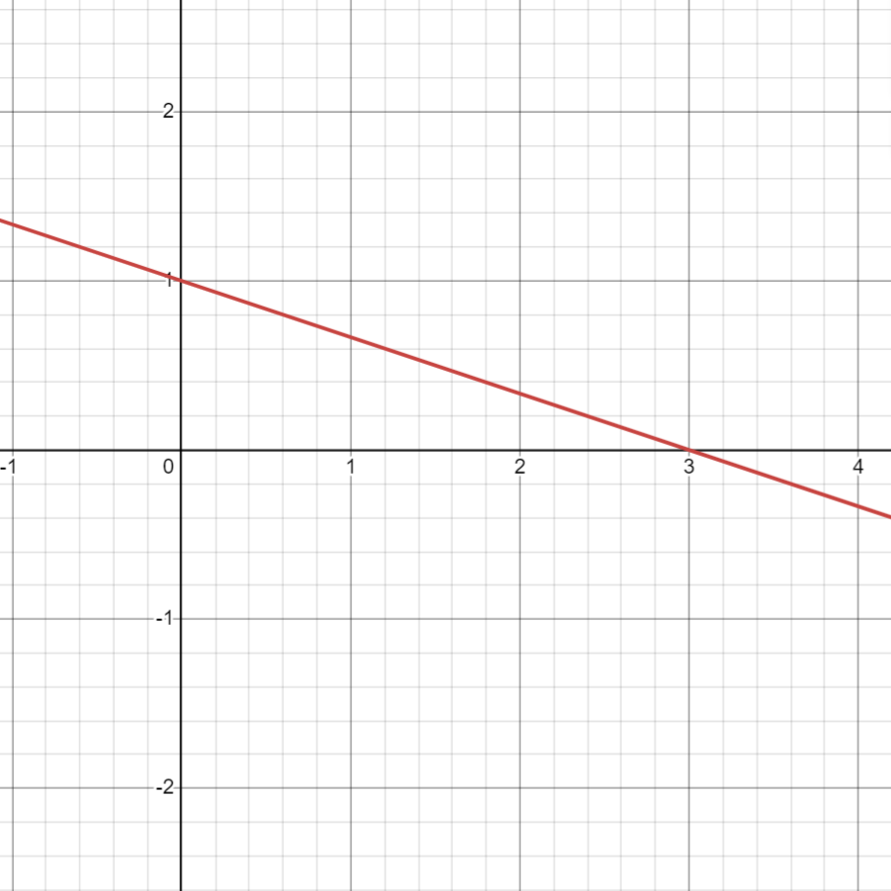
c.  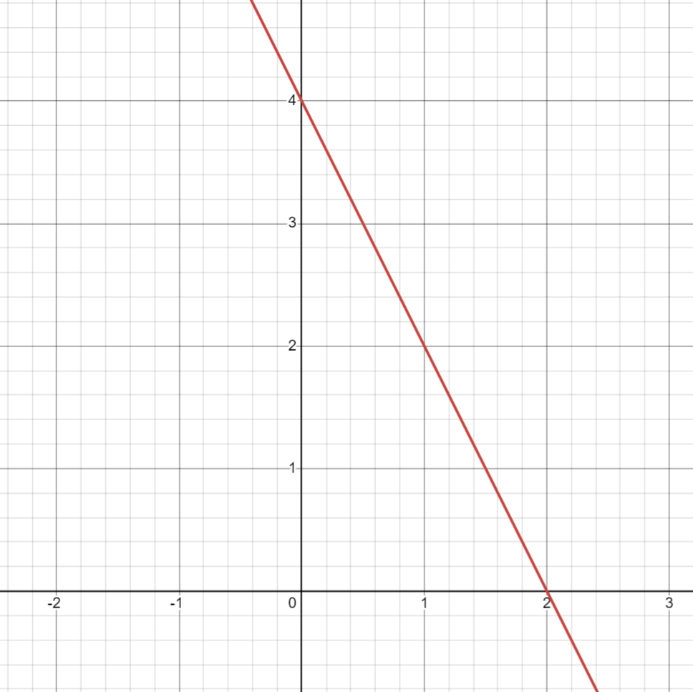 | f.  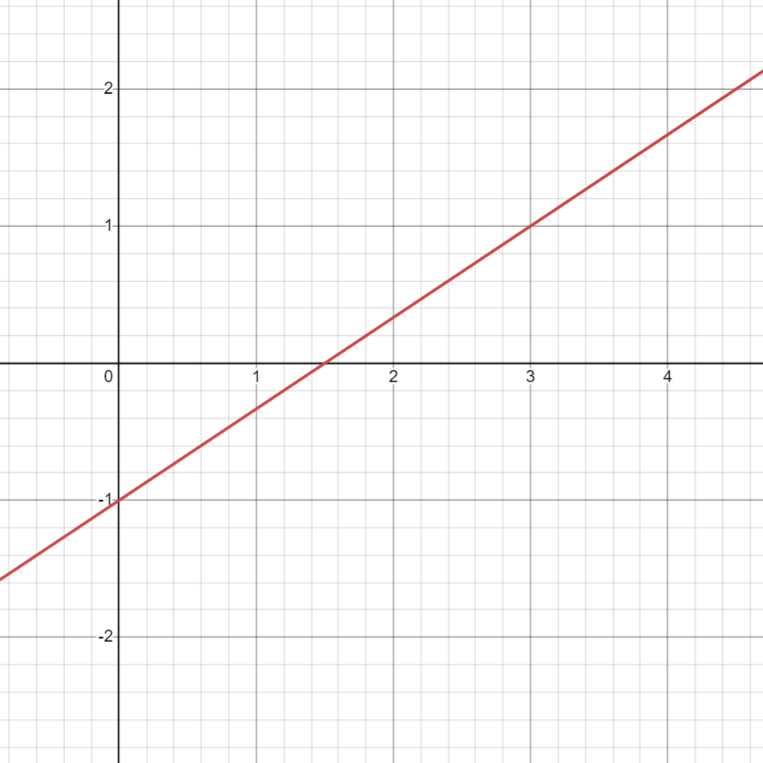

Use the slope formula to determine the slope between the following sets of points.
a. $(3, 4)$ and $(7, 2)$

b. $(-3, 5)$ and $(-3, 7)$

c. $(-1, -2)$ and $(-3, 4)$

d. $(4, 5)$ and $(-3, 5)$

e. $(-\frac{1}{2}, 3)$ and $(\frac{1}{4}, 2)$

Answers Key
First portion:
a. 2 b. 0 c. -2 d. undefined e. $-\frac{1}{3}$ f. $\frac{2}{3}$
Second portion:
a. $m=-\frac{1}{2}$ b. undefined c. $m=-3$ d. $m=0$ e. $m=-\frac{4}{3}$

