A Review of Functions
What is the definition of a function?

What is the notation for a function?

Let $f\left(x\right)=x^{2}-3x+1$ and $g\left(x\right)=4x+5$. Evaluate the following:
a. $f\left(-2\right)$

b. $g(5)$

c. $g(a-4)$

d. $f(x+h)$

What is the domain?

What is the range?

Explain the relationship between a domain and range for a function:

One easy way to determine if an equation is a function is with the vertical line test. Use the vertical line test to determine if the following are functions. (Graphs provided by desmos.com)
a.  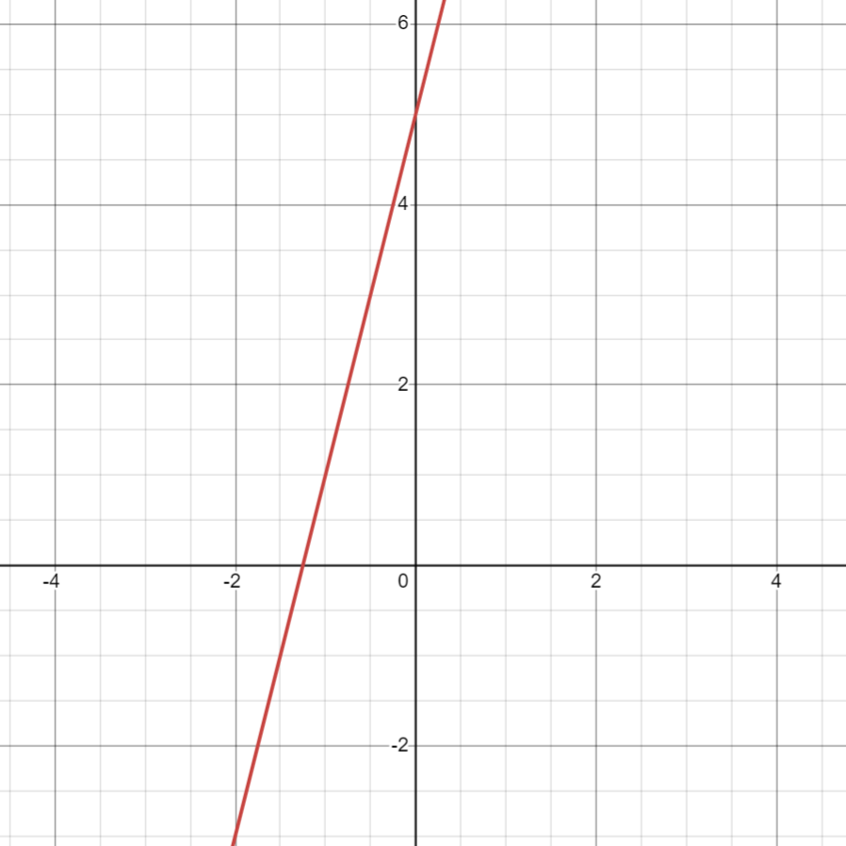 | b.  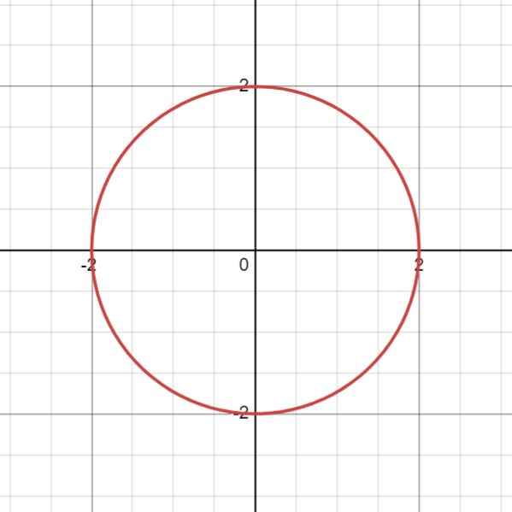
c.  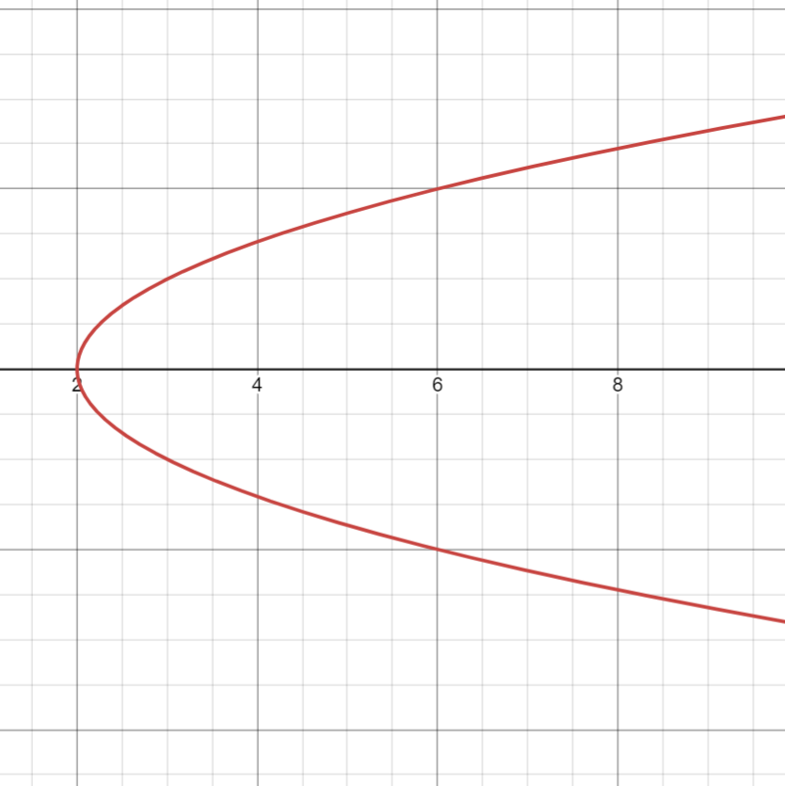 | d.  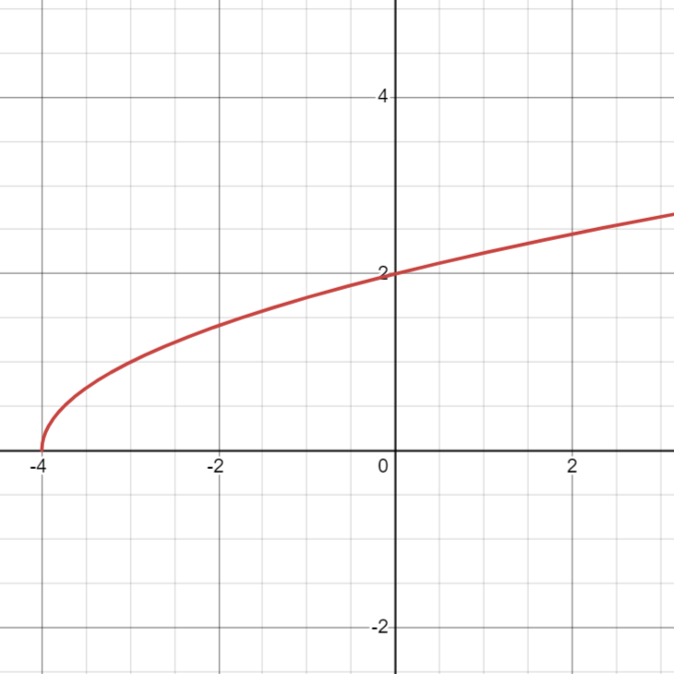
Show how to graph $f\left(x\right)=4x-1$
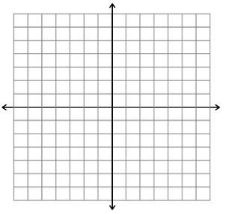
Next we will discuss different operations with functions.
Let $f\left(x\right)=5x-2, g\left(x\right)=x-2, h\left(x\right)=x^{2}-4$. Find the value of the following.
a. $(f+g)(x)$

b. $(f*h)(x)$

c. $(f+g)(3)$

d. $(f-g)(-2)$

e. $\left(\frac{h}{g}\right)\left(x\right)$

We also need to discuss the composition of functions. What does $(f ∘g)(x)$ mean?

Let $f\left(x\right)=5x-2, g\left(x\right)=x-2, h\left(x\right)=x^{2}-4$. Find the value of the following.
a. $(f∘g)(x)$

b. $(h∘f)(x)$

c. $(g∘f)(x)$

d. $(g∘h)(3)$

