A Review of Inverse Functions
What is the definition of an inverse function?

Only one-to-one functions have inverses. What are one-to-one functions?

How can you visualize the relationship between the domain and range for a one-to-one function?

One way to determine a one-to-one function is with the horizontal line test. Describe what that is.

Which of the following are both functions and one-to-one functions? (Graphs provided by Desmos.com)
a.  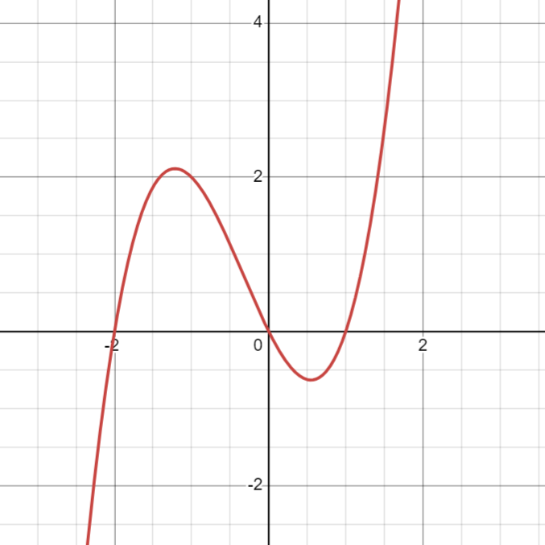 | b.  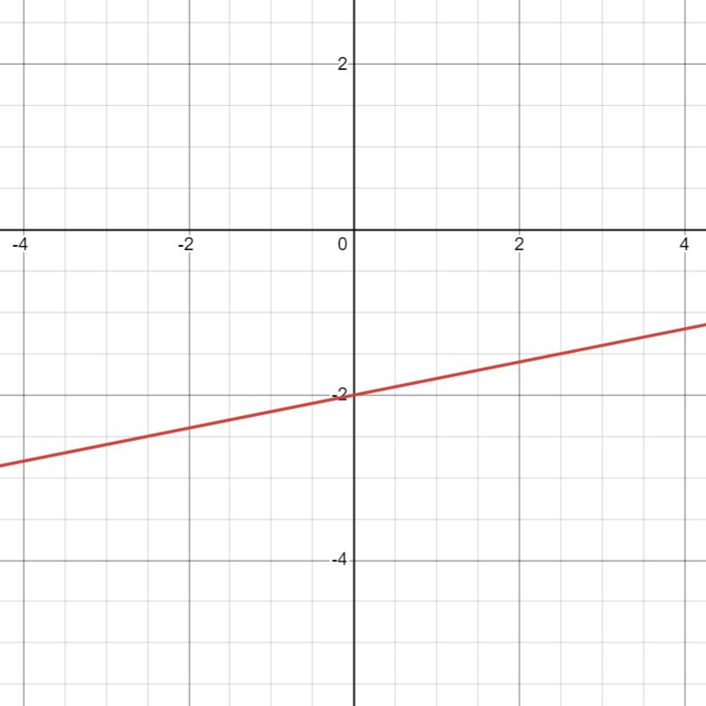
c.  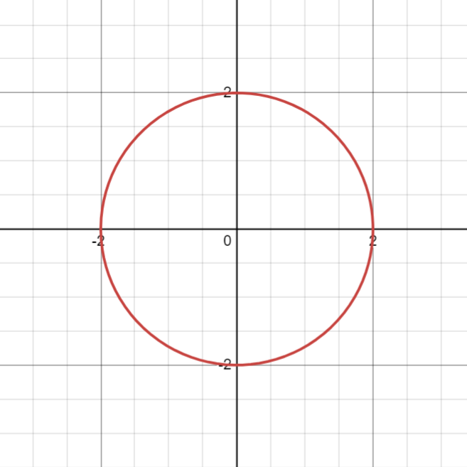 | d.  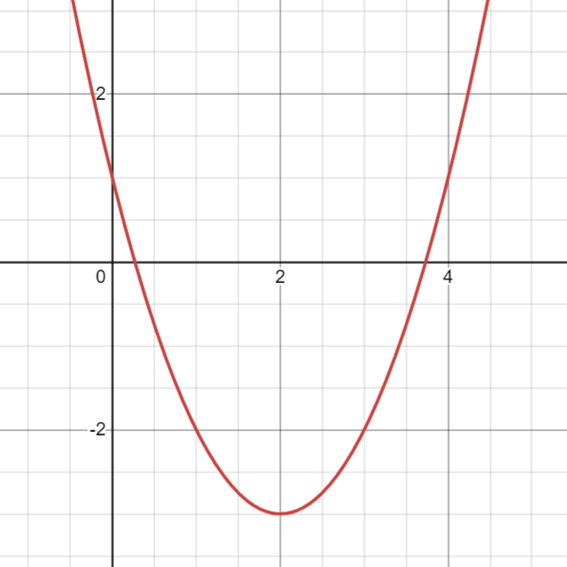
e.  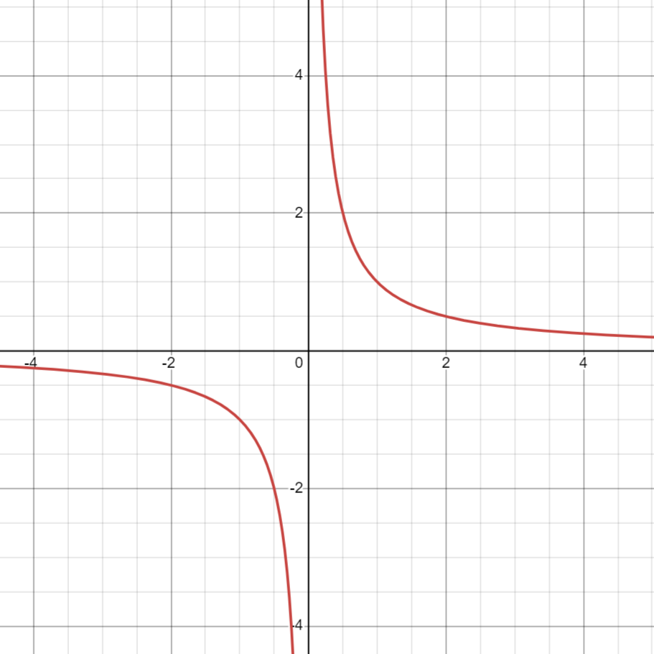 | f.  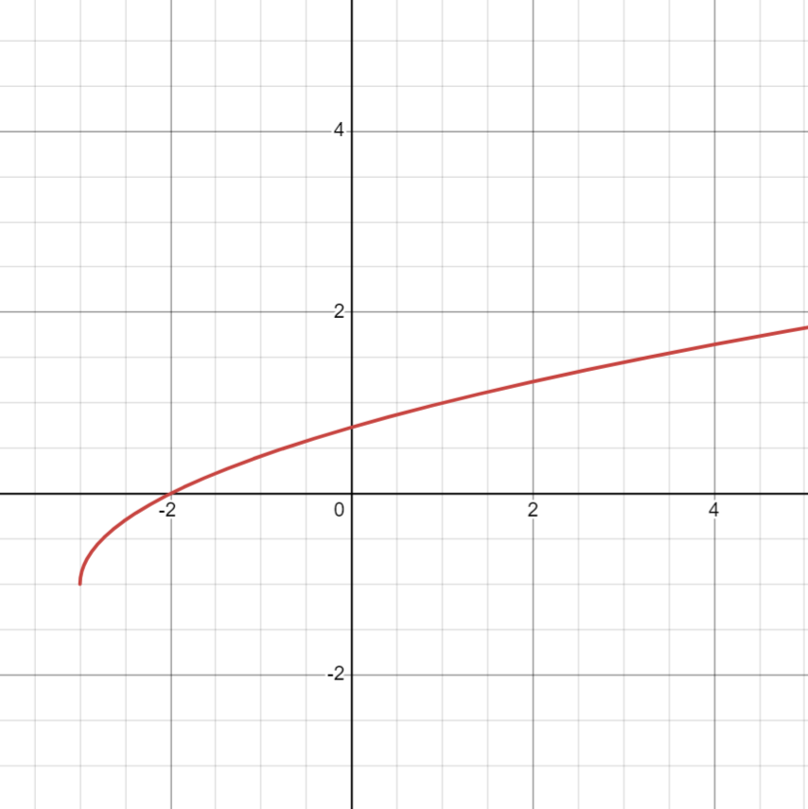

Which is the following functions defined only by the set of points have inverses? What is the inverse?
a. $\{ \left(3, 4\right), \left(7,2\right), \left(-2, 5\right)\}$

b. $\{\left(4, -2\right), \left(-1, -3\right), \left(7, -2\right)\}$

c. $\left\{\left(5, 2\right), \left(6, 3\right), \left(5, 7\right)\right\}$

Explain how to find the inverse of a function using the function $f\left(x\right)=3x-2$

Find the inverse of the following functions.
a. $f\left(x\right)=4x-2$

b. $g\left(x\right)=x^{3}$

c. $f\left(x\right)=-\frac{5}{x-2}$

d. $g\left(x\right)=\sqrt{x}+2$

