A Review of Exponentials– More Practice!!!
Graph the following.
a. $f\left(x\right)=3^{x}$
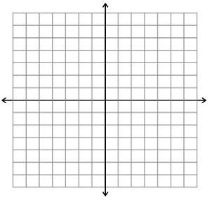
b. $g\left(x\right)={\left(\frac{1}{4}\right)}^{x}$
c. $f\left(x\right)={\left(\frac{1}{3}\right)}^{x}$

Solve the following equations.
a. $4^{x}=16$

b. $5^{x}=\frac{1}{125}$

c. $2^{3x}={16}^{x-2}$

d. ${25}^{4x}={125}^{2x-4}$

e. ${\left(\frac{1}{8}\right)}^{2x}={16}^{3x+2}$

Answer Key
Graphing Section
a. b.
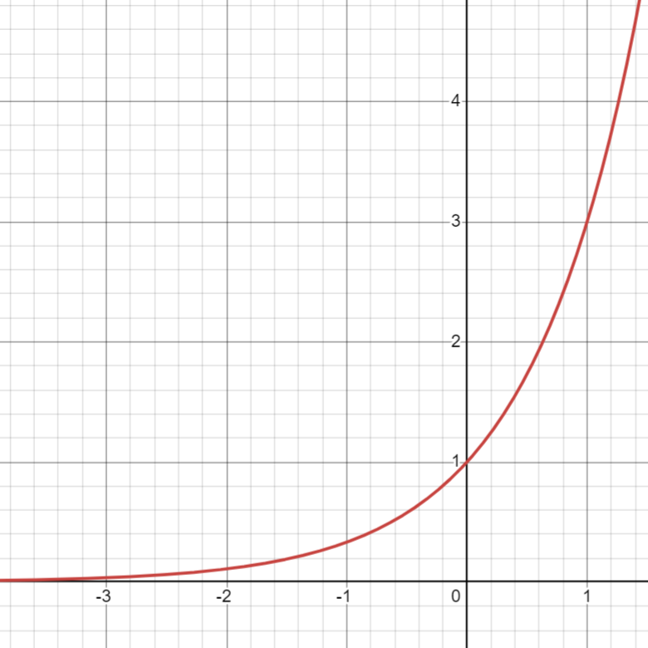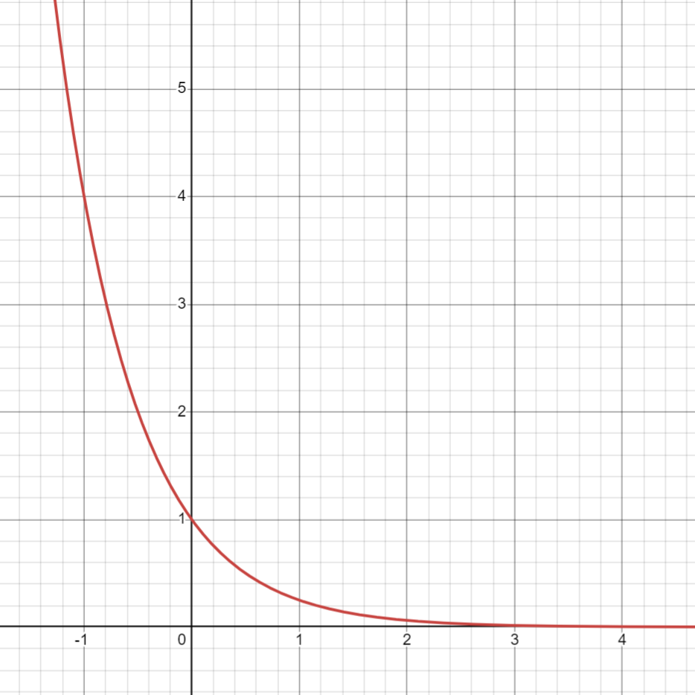
c.
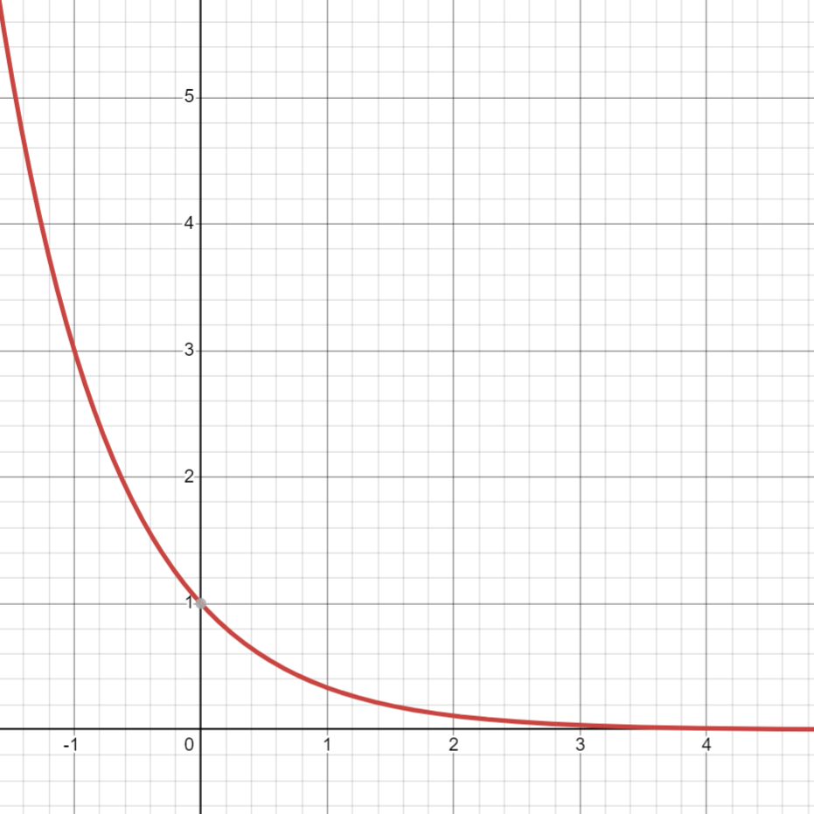

Equations Section:
$a.x=2 b. x=-3 c. x=8 d.x=-6 e. x=-\frac{4}{9}$

