Chapter 1 Part 1 Notes: Sections 1.1 – 1.2 and Excel Lab 1
Section 1.1: Definitions of Statistics, Probability, and Key Terms
The science of statistics deals with the collection, analysis, interpretation, and presentation of data. We see and use data in our everyday lives.
What are the 3 main aspects of statistics that we will study?

Definitions: Population and Parameter
- In statistics, we generally want to study a population. You can think of a population as a collection of persons, things, or objects under study.
- The statistic is an estimate of a population parameter. A parameter is a number that is a property of the population.
Write one example from the video of a parameter for a population, and then come up with your own example:

What is the issue with finding many true population parameters?

How do we resolve this issue with finding a true population parameter?

Definition: Variables, Data, and Representative Samples
- A variable, notated by capital letters such as X and Y, is a characteristic of interest for each person or thing in a population. Variables may be numerical or categorical.
- Numerical variables take on values with equal units such as weight in pounds and time in hours.
- Categorical variables place the person or thing into a category.
- Data are the actual values of the variable. They may be numbers or they may be words. Datum is a single value. Data are the result of sampling from a population.
- The sample must contain the characteristics of the population in order to be a representative sample. We are interested in both the sample statistic and the population parameter in inferential statistics.
Give an example of 2 situations where a representative sample was not used. You may use one example from the video, and then come up with your own example.

Two frequently used statistics that we compute are a mean and a proportion.
- Show how to compute the mean of these three test scores: 72, 88, 85

- In a particular county, 453 out of 723 residents voted in the last election. What proportion is this?

Example A study was conducted at a local college to analyze the average cumulative GPA’s of students who graduated last year. Fill in the letter of the phrase that best describes each of the items below.
1. Population____________
2. Statistic____________
3. Parameter____________
4. Sample____________
5. Variable____________
6. Data____________
- all students who attended the college last year
- the cumulative GPA of one student who graduated from the college last year
- 3.65, 2.80, 1.50, 3.90
- a group of students who graduated from the college last year, randomly selected
- the average cumulative GPA of students who graduated from the college last year
- all students who graduated from the college last year
- the average cumulative GPA of students in the study who graduated from the college last year

Example For the following situation, identify: a. the population, b. the sample, c. the parameter, d. the statistic, e. the variable, and f. the data. We want to know the average (mean) amount of money first year college students spend at ABC College on school supplies that do not include books. We randomly surveyed 100 first year students at the college. Three of those students spent $150, $200, and $225, respectively.
- Population:

- Statistic:

- Parameter:

- Sample:

- Variable:

- Data:

Example For the following situation, identify: a. the population, b. the sample, c. the parameter, d. the statistic, e. the variable, and f. the data. Ski resorts are interested in the mean age that children take their first ski and snowboard lessons. They need this information to plan their ski classes optimally.
- Population:

- Statistic:

- Parameter:

- Sample:

- Variable:

- Data:

Section 1.2: Data, Sampling, and Variation in Data and Sampling
Explain the difference between quantitative versus qualitative data. Explain the different types.

Vocabulary for Quantitative Data
- Quantitative data may be either discrete or continuous.
- All data that are the result of counting are called quantitative discrete data. These data take on only certain numerical values.
- All data that are the result of measuring are quantitative continuous data assuming that we can measure accurately.

Example Indicate whether quantitative data are continuous or discrete. Hint: Data that are discrete often start with the words "the number of."
the number of pairs of shoes you own

the type of car you drive

the distance it is from your home to the nearest grocery store

the number of classes you take per school year

the type of calculator you use

weights of sumo wrestlers

number of correct answers on a quiz

IQ scores

Explain the differences between the following ways to visualize data:
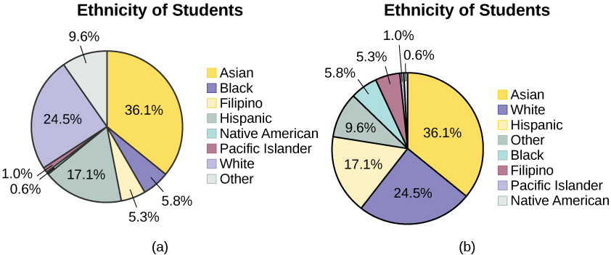
How are these pie charts different?

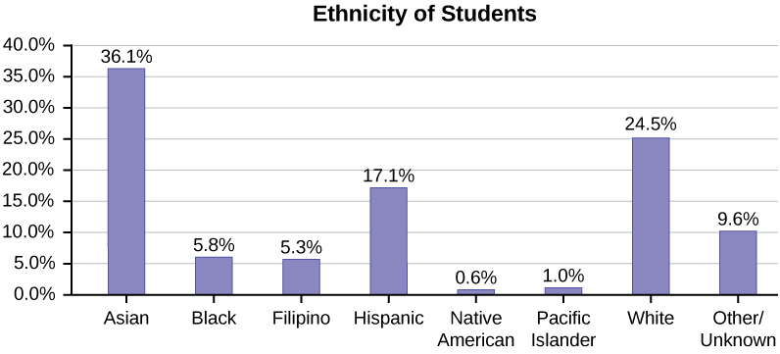
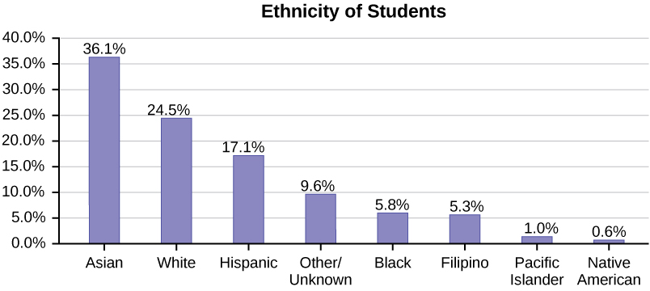
How are the bar charts different?

Example A statistics professor collects information about the classification of her students as freshmen, sophomores, juniors, or seniors. The data she collects are summarized in the pie chart. What type of data does this graph show?
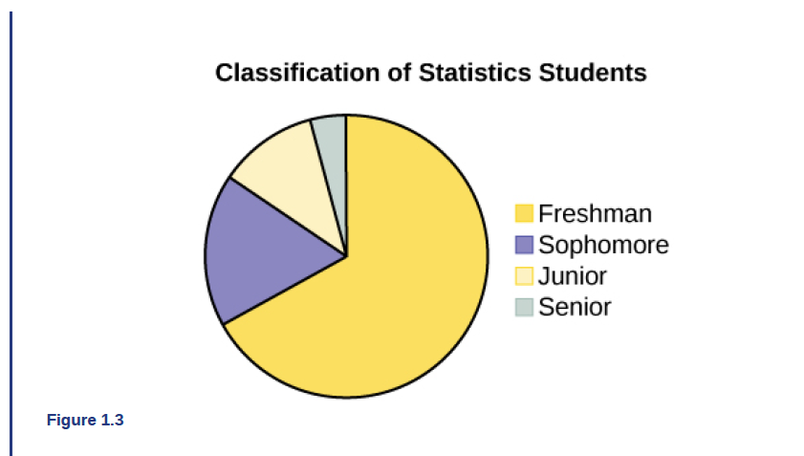

What are 2 ways to do sampling? Give an example to explain the difference between these types of sampling.

Notes on Sampling Methods:
- Besides simple random sampling, there are other forms of sampling that involve a chance process for getting the sample. Other well-known random sampling methods are the stratified sample, the cluster sample, and the systematic sample.
- To choose a stratified sample, divide the population into groups called strata and then take a proportionate number from each stratum.
- To choose a cluster sample, divide the population into clusters (groups) and then randomly select some of the clusters. All the members from these clusters are in the cluster sample.
- To choose a systematic sample, randomly select a starting point and take every nth piece of data from a listing of the population.
- A type of sampling that is non-random is convenience sampling. Convenience sampling involves using results that are readily available.
Notes on Sampling Errors and Bias:
- When you analyze data, it is important to be aware of sampling errors and nonsampling errors.
- The actual process of sampling causes sampling errors. For example, the sample may not be large enough.
- Factors not related to the sampling process cause nonsampling errors. A defective counting device can cause a nonsampling error.
- In statistics, a sampling bias is created when a sample is collected from a population and some members of the population are not as likely to be chosen as others (remember, each member of the population should have an equally likely chance of being chosen).
- When a sampling bias happens, there can be incorrect conclusions drawn about the population that is being studied.
Notes on Variation in Data:
- Variation is present in any set of data.
  - An example: 16-ounce cans of beverage may contain more or less than 16 ounces of liquid.
- It was mentioned previously that two or more samples from the same population, taken randomly, and having close to the same characteristics of the population will likely be different from each other.
- If Doreen and Jung took larger samples (i.e. the number of data values is increased), their sample results (the average amount of time a student sleeps) might be closer to the actual population average. But still, their samples would be, in all likelihood, different from each other. This variability in samples cannot be stressed enough.

Example Determine the type of sampling used (simple random, stratified, systematic, cluster, or convenience).
A soccer coach selects six players from a group of boys aged eight to ten, seven players from a group of boys aged 11 to 12, and three players from a group of boys aged 13 to 14 to form a recreational soccer team.

A pollster interviews all human resource personnel in five different high tech companies.

A high school educational researcher interviews 50 high school female teachers and 50 high school male teachers.

A medical researcher interviews every third cancer patient from a list of cancer patients at a local hospital.

A high school counselor uses a computer to generate 50 random numbers and then picks students whose names correspond to the numbers.

A student interviews classmates in his algebra class to determine how many pairs of jeans a student owns, on the average.

Example Suppose ABC College has 10,000 part-time students (the population). We are interested in the average amount of money a part-time student spends on books in the fall term. Asking all 10,000 students is an almost impossible task. Suppose we take two different samples. It is unlikely that any student is in both samples.
First, we use convenience sampling and survey ten students from a first term organic chemistry class. Many of these students are taking first term calculus in addition to the organic chemistry class. The amount of money they spend on books is as follows:
$128; $87; $173; $116; $130; $204; $147; $189; $93; $153
The second sample is taken using a list of senior citizens who take P.E. classes and taking every fifth senior citizen on the list, for a total of ten senior citizens. They spend:
$50; $40; $36; $15; $50; $100; $40; $53; $22; $22
- Do you think that either of these samples is representative of (or is characteristic of) the entire 10,000 part-time student population?

- Since these samples are not representative of the entire population, is it wise to use the results to describe the entire population?

Now, suppose we take a third sample. We choose ten different part-time students from the disciplines of chemistry, math, English, psychology, sociology, history, nursing, physical education, art, and early childhood development. (We assume that these are the only disciplines in which part-time students at ABC College are enrolled and that an equal number of part-time students are enrolled in each of the disciplines.) Each student is chosen using simple random sampling. Using a calculator, random numbers are generated and a student from a particular discipline is selected if he or she has a corresponding number. The students spend the following amounts:
$180; $50; $150; $85; $260; $75; $180; $200; $200; $150
Is the sample biased? Explain.

Excel Lab 1
Explain the difference between the different types of crosses in Excel.

What symbol indicates that you want Excel to compute anything?

What formulas were discussed in the lab.

What symbol indicates you want to lock part of a cell? Explain how cells can be locked.

Submitting this Assignment to Blackboard
For every notes assignment, you will submit the notes + any completed Excel labs associated with the notes. In this first assignment, you will submit of these notes + the Excel lab 1 file to Blackboard. They should all be in the same submission!

