Chapter 2 Part 1 Notes
A general note: We will be using “Excel Lab 3” throughout these notes. You might want to hand it handy.
Section 2.1: Stem-and-Leaf Graphs (Stemplots), Line Graphs, and Bar Graphs
What are stem-and-leaf graphs?
- One simple graph, the stem-and-leaf graph or stemplot, comes from the field of exploratory data analysis. It is a good choice when the data sets are small.
- To create the plot, divide each observation of data into a stem and a leaf. The leaf consists of a final significant digit.
- Write the stems in a vertical line from smallest to largest. Draw a vertical line to the right of the stems. Then write the leaves in increasing order next to their corresponding stem.
For the number 23, what is the stem versus what is the leaf?

For the number 432, what is the stem and what is the leaf?

For the number 5,432, what is the stem and what is the leaf?

For the decimal 9.3, what is the stem and what is the leaf?

What can stem-and-leaf graphs be good for?

Example For Susan Dean's spring pre-calculus class, scores for the first exam were as follows (smallest to largest):
33; 42; 49; 49; 53; 55; 55; 61; 63; 67; 68; 68; 69; 69; 72; 73; 74; 78; 80; 83; 88; 88; 88; 90; 92; 94; 94; 94; 94; 96; 100
Make a stem-and-leaf plot of this situation.

Where are the majority of the exam scores in this graph?

Example A side-by-side stem-and-leaf plot allows a comparison of the two data sets in two columns. In a side-by-side stem-and-leaf plot, two sets of leaves share the same stem. The leaves are to the left and the right of the stems. Table 2.4 and Table 2.5 show the ages of presidents at their inauguration and at their death. Note the construction of a side-by-side stem-and-leaf plot using this data.
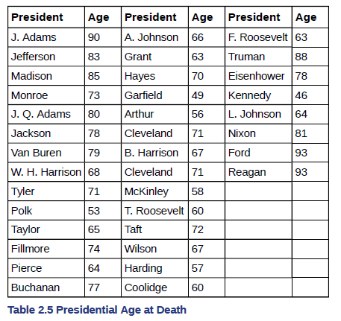
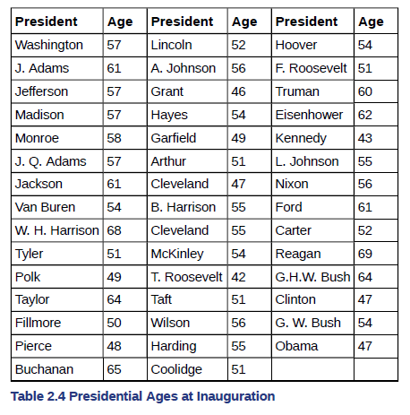

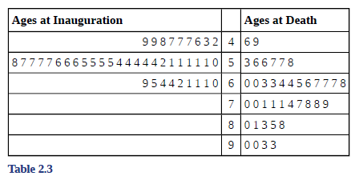

Can we make stem-and-leaf plots in Excel?

What are lines graphs?
- Another type of graph that is useful for specific data values is a line graph.
- The x-axis (horizontal axis) consists of data values and the y-axis (vertical axis) consists of frequency points.
- The frequency points are connected using line segments.
Example of a Line Graph In a survey, 40 mothers were asked how many times per week a teenager must be reminded to do his or her chores. The results are shown in Table 2.7 and in Figure 2.2.
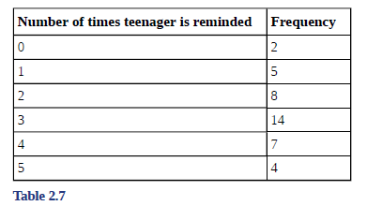

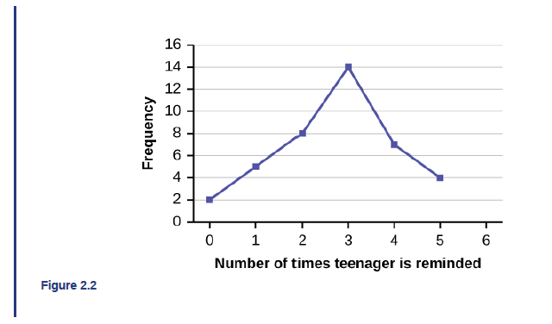

What are bar graphs?
- Bar graphs consist of bars that are separated from each other.
- The bars can be rectangles or they can be rectangular boxes (used in three-dimensional plots), and they can be vertical or horizontal.

Example of a Bar Graph
By the end of 2011, Facebook had over 146 million users in the United States. Table 2.9 shows three age groups, the number of users in each age group, and the proportion (%) of users in each age group. A bar graph of this data is shown below.
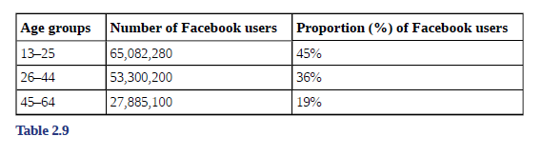
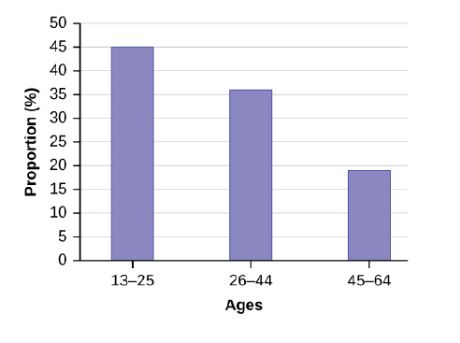

Example (Excel Lab 3 file) In a survey, 40 people were asked how many times per year they had their car in the shop for repairs. The results are shown in Table 2.8 and the chapter Excel file. Construct a line graph and a bar graph. Write out instructions for how to do this so you do not forget.
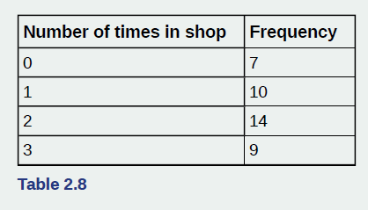

Section 2.2: Histograms, Frequency Polygons, and Time Series Graphs
What is a histogram?
- A histogram consists of contiguous (adjoining) boxes. It has both a horizontal axis and a vertical axis.
- The horizontal axis is labeled with what the data represents (for instance, distance from your home to school).
- The vertical axis is labeled either frequency or relative frequency (or percent frequency or probability).
- The graph will have the same shape with either label.
- The histogram (like the stemplot) can give you the shape of the data, the center, and the spread of the data.
How to Construct a Histogram?
- To construct a histogram, first decide how many bars or intervals, also called classes, represent the data. Many histograms consist of five to 15 bars or classes for clarity.
- Choose a starting point for the first interval to be less than the smallest data value. A convenient starting point is a lower value carried out to one more decimal place than the value with the most decimal places.
  - For example, if the value with the most decimal places is 6.1 and this is the smallest value, a convenient starting point is 6.05 (6.1 – 0.05 = 6.05). If all the data happen to be integers and the smallest value is two, then a convenient starting point is 1.5 (2 – 0.5 = 1.5).
- Also, when the starting point and other boundaries are carried to one additional decimal place, no data value will fall on a boundary.
- Next, calculate the width of each bar or class interval. To calculate this width, subtract the starting point from the ending value and divide by the number of bars (you must choose the number of bars you desire).

Example The following data are the heights (in inches to the nearest half inch) of 100 male semiprofessional soccer players. The heights are continuous data, since height is measured.
60; 60.5; 61; 61; 61.5
63.5; 63.5; 63.5
64; 64; 64; 64; 64; 64; 64; 64.5; 64.5; 64.5; 64.5; 64.5; 64.5; 64.5; 64.5
66; 66; 66; 66; 66; 66; 66; 66; 66; 66; 66.5; 66.5; 66.5; 66.5; 66.5; 66.5; 66.5; 66.5; 66.5; 66.5; 66.5; 67; 67; 67; 67; 67; 67; 67; 67; 67; 67; 67; 67; 67.5; 67.5; 67.5; 67.5; 67.5; 67.5; 67.5
68; 68; 69; 69; 69; 69; 69; 69; 69; 69; 69; 69; 69.5; 69.5; 69.5; 69.5; 69.5
70; 70; 70; 70; 70; 70; 70.5; 70.5; 70.5; 71; 71; 71
72; 72; 72; 72.5; 72.5; 73; 73.5
74
What is the smallest data value?

How do we decide to create the starting value for our histogram then? Write out a few acceptable starting values.

Now choose the ending value for our histogram. Explain the reasoning.

Explain how to create different intervals from this point.

Below is an example of how the histogram could look:
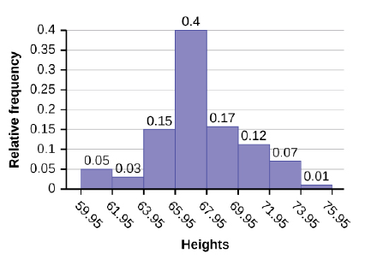
Now refer to Excel Lab 3 to create this example in Excel. Write out any relevant instructions on how to create histograms.

What are frequency polygons?
- Frequency polygons are analogous to line graphs, and just as line graphs make continuous data visually easy to interpret, so too do frequency polygons.
- To construct a frequency polygon, first examine the data and decide on the number of intervals, or class intervals, to use on the x-axis and y-axis.
- After choosing the appropriate ranges, begin plotting the data points.
- After all the points are plotted, draw line segments to connect them.

Example of a Frequency Polygon
A frequency polygon was constructed from the frequency table below.
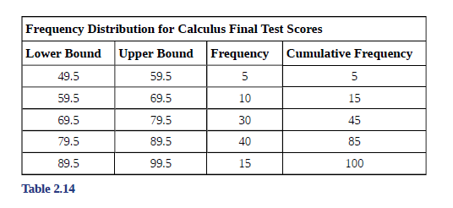

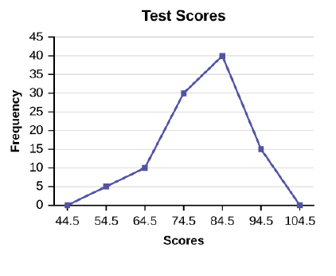

What are time series graphs?
- To construct a time series graph, we must look at both pieces of our paired data set. We start with a standard Cartesian coordinate system.
- The horizontal axis is used to plot the date or time increments, and the vertical axis is used to plot the values of the variable that we are measuring. By doing this, we make each point on the graph correspond to a date and a measured quantity.
- The points on the graph are typically connected by straight lines in the order in which they occur.

Example of a Time Series Graph
The following data shows the Annual Consumer Price Index, each month, for ten years. Construct a time series graph for the Annual Consumer Price Index data only. See next slide for graph.
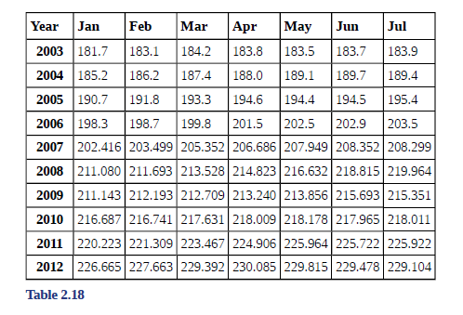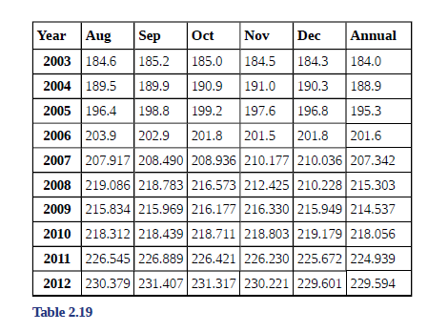
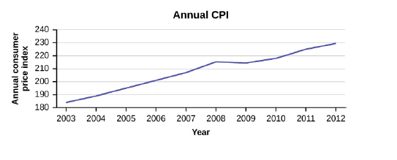

Example (Excel Lab 3 file) The following table is a portion of a data set from www.worldbank.org. Use the table to construct a time series graph for CO2 emissions for the United States. See Excel file.
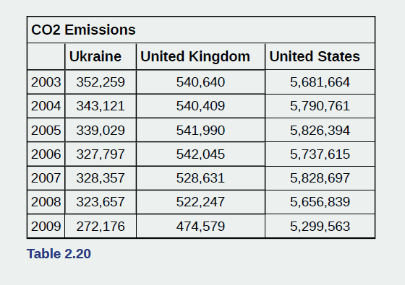

Section 2.3: Measures of the Location of the Data
What is the median?
- The median is a number that measures the "center" of the data.
- You can think of the median as the "middle value," but it does not actually have to be one of the observed values.
- It is a number that separates ordered data into halves. Half the values are the same number or smaller than the median, and half the values are the same number or larger.
- The median, M, is called both the second quartile and the 50th percentile.
What are percentiles or quartiles?
- The common measures of location are quartiles and percentiles.
- Percentiles divide ordered data into hundredths.
- To score in the 90th percentile of an exam does not mean, necessarily, that you received 90% on a test. It means that 90% of test scores are the same or less than your score and 10% of the test scores are the same or greater than your test score.
- To calculate percentiles, the data must be ordered from smallest to largest.
- Quartiles divide ordered data into quarters.
- The first quartile, Q1, is the middle value of the lower half of the data, and the third quartile, Q3, is the middle value of the upper half of the data.
- The first quartile, Q1, is the same as the 25th percentile, and the third quartile, Q3, is the same as the 75th percentile.
- Quartiles may or may not be part of the data.
- To calculate quartiles, the data must be ordered from smallest to largest.

Explain the difference between the different ways to compute quartiles:

What Is interquartile range (IQR)?
- The interquartile range is a number that indicates the spread of the middle half or the middle 50% of the data.
- The IQR can help to determine potential outliers.
- A value is suspected to be a potential outlier if it is less than (1.5)(IQR) below the first quartile or more than (1.5)(IQR) above the third quartile. Potential outliers always require further investigation.
- NOTE: A potential outlier is a data point that is significantly different from the other data points. These special data points may be errors or some kind of abnormality or they may be a key to understanding the data.
What is the formula to compute IQR?

Example For the following 13 real estate prices:
389,950; 230,500; 158,000; 479,000; 639,000; 114,950; 5,500,000; 387,000; 659,000; 529,000; 575,000; 488,800; 1,095,000
Compute Q1, Q2, Q3, and IQR using:
The Tukey method

The M&M method

The Excel formulas (you will use Excel Lab 3)

Which method should you use?

Example On a timed math test, the first quartile for time it took to finish the exam was 35 minutes. Interpret the first quartile in the context of this situation.

State the formula for finding the kth percentile:

Example Listed are 29 ages for Academy Award winning best actors in order from smallest to largest.
18; 21; 22; 25; 26; 27; 29; 30; 31; 33; 36; 37; 41; 42; 47; 52; 55; 57; 58; 62; 64; 67; 69; 71; 72; 73; 74; 76; 77
- Find the 70th percentile.

- Find the 83rd percentile.

State the formula for finding the percentile of a particular data value in a data set:

Example Listed are 29 ages for Academy Award winning best actors in order from smallest to largest.
18; 21; 22; 25; 26; 27; 29; 30; 31; 33; 36; 37; 41; 42; 47; 52; 55; 57; 58; 62; 64; 67; 69; 71; 72; 73; 74; 76; 77
- Find the percentile for 58.

- Find the percentile for 25.

You will finish the set of notes by redoing these same exercises in Excel. Write down any relevant notes that you might want to remember about that exercise here:
Example Listed are 29 ages for Academy Award winning best actors in order from smallest to largest.
18; 21; 22; 25; 26; 27; 29; 30; 31; 33; 36; 37; 41; 42; 47; 52; 55; 57; 58; 62; 64; 67; 69; 71; 72; 73; 74; 76; 77
- Find the 70th percentile.

- Find the 83rd percentile.

Example Listed are 29 ages for Academy Award winning best actors in order from smallest to largest.
18; 21; 22; 25; 26; 27; 29; 30; 31; 33; 36; 37; 41; 42; 47; 52; 55; 57; 58; 62; 64; 67; 69; 71; 72; 73; 74; 76; 77
- Find the percentile for 58.

- Find the percentile for 25.

