Chapter 2 Part 1 Notes
A general note: We will be using “Excel Lab 4” throughout these notes. You might want to hand it handy.
Section 2.4: Box Plots
What are box plots?
- Box plots (also called box-and-whisker plots or box-whisker plots) give a good graphical image of the concentration of the data.
- They also show how far the extreme values are from most of the data.
- A box plot is constructed from five values: the minimum value, the first quartile, the median, the third quartile, and the maximum value.
- To construct a box plot, use a horizontal or vertical number line and a rectangular box.
- The smallest and largest data values label the endpoints of the axis. The first quartile marks one end of the box and the third quartile marks the other end of the box. Approximately the middle 50 percent of the data fall inside the box. The "whiskers" extend from the ends of the box to the smallest and largest data values.
- The median or second quartile can be between the first and third quartiles, or it can be one, or the other, or both. The box plot gives a good, quick picture of the data.
- NOTE: You may encounter box-and-whisker plots that have dots marking outlier values. In those cases, the whiskers are not extending to the minimum and maximum values.
- The two whiskers extend from the first quartile to the smallest value and from the third quartile to the largest value. The median is shown with a dashed line.
- NOTE: It is important to start a box plot with a scaled number line. Otherwise the box plot may not be useful.
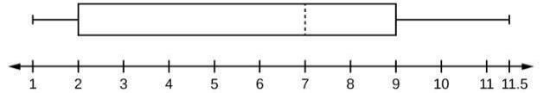

Example The following data are the heights of 40 students in a statistics class.
59; 60; 61; 62; 62; 63; 63; 64; 64; 64; 65; 65; 65; 65; 65; 65; 65; 65; 65; 66; 66; 67; 67; 68; 68; 69; 70; 70; 70; 70; 70; 71; 71; 72; 72; 73; 74; 74; 75; 77
Construct a box plot.
- Minimum value = 59
- Maximum value = 77
- Q1: First quartile = 64.5
- Q2: Second quartile or median= 66
- Q3: Third quartile = 70

Example with Excel: Use Excel to construct a box plot with the following data. Draw a sketch of your box plot below, and write any relevant notes on how you created the box plot so that you don’t forget!
0; 5; 5; 15; 30; 30; 45; 50; 50; 60; 75; 110; 140; 240; 330

Section 2.5: Measures of the Center of the Data
What are measure of center?
- The "center" of a data set is also a way of describing location. The two most widely used measures of the "center" of the data are the mean (average) and the median.
- To calculate the mean weight of 50 people, add the 50 weights together and divide by 50.
- To find the median weight of the 50 people, order the data and find the number that splits the data into two equal parts.
- NOTE: The words “mean” and “average” are often used interchangeably. The substitution of one word for the other is common practice. The technical term is “arithmetic mean” and “average” is technically a center location. However, in practice among non-statisticians, “average" is commonly accepted for “arithmetic mean.”
What notation is used to denoted a population mean versus a sample mean?

More about the median:
- If the total number of data values in the sample is an odd number, the median is the middle value of the ordered data (ordered smallest to largest).
- If the total number of data values in the sample is an even number, the median is equal to the two middle values added together and divided by two after the data has been ordered.
- The location of the median and the value of the median are not the same.
- The upper case letter M is often used to represent the median.

Example AIDS data indicating the number of months a patient with AIDS lives after taking a new antibody drug are as follows (smallest to largest):
3; 4; 8; 8; 10; 11; 12; 13; 14; 15; 15; 16; 16; 17; 17; 18; 21; 22; 22; 24; 24; 25; 26; 26; 27; 27; 29; 29; 31; 32; 33; 33; 34; 34; 35; 37; 40; 44; 44; 47
Calculate the mean and the median.

What is the mode?
- Another measure of the center is the mode. The mode is the most frequent value.
- There can be more than one mode in a data set as long as those values have the same frequency and that frequency is the highest. A data set with two modes is called bimodal.
- NOTE: The mode can be calculated for qualitative data as well as for quantitative data. For example, if the data set is: red, red, red, green, green, yellow, purple, black, blue, the mode is red.
Example Five real estate exam scores are 430, 430, 480, 480, 495. What is the mode?

In a sample of 60 households, one house is worth $2,500,000. Half of the rest are worth $280,000, and all the others are worth $315,000. Which is the better measure of the “center”: the mean, median, or mode?

How can a mean be calculated from a frequency table?
- When only grouped data is available, you do not know the individual data values (we only know intervals and interval frequencies); therefore, you cannot compute an exact mean for the data set.
- What we must do is estimate the actual mean by calculating the mean of a frequency table.
- A frequency table is a data representation in which grouped data is displayed along with the corresponding frequencies.
- To find the mean of a frequency table, we simply need to modify the definition to fit within the restrictions of a frequency table.
  - Since we do not know the individual data values we can instead find the midpoint of each interval. The midpoint is $\frac{lower boundary+upper boundary}{2}$
  - The mean definition for frequency is: $mean frequency=\frac{Σfm}{Σf},$ f=frequency of the interval, m=midpoint

Example A frequency table displaying professor Blount’s last statistic test is shown. Find the best estimate of the class mean. See the Excel spreadsheet for data. Write down any relevant notes on this page about how you computed this mean in Excel.
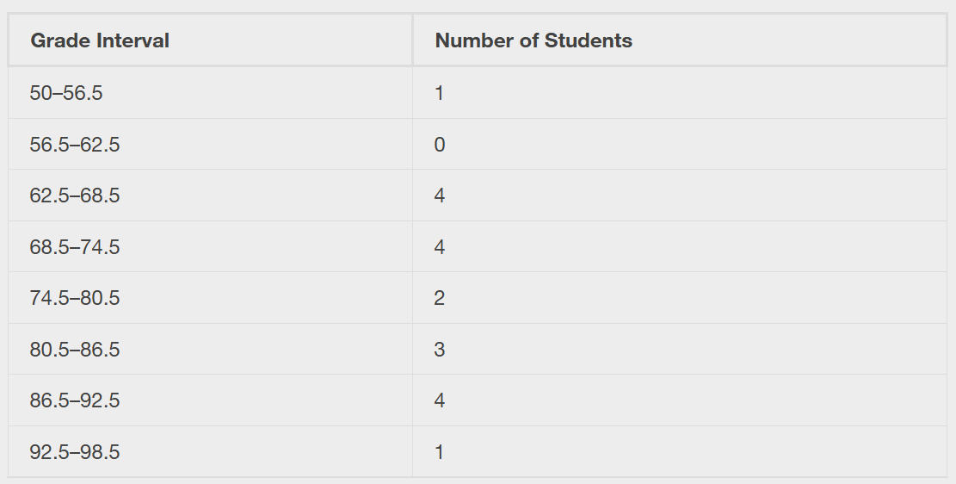

Section 2.6: Skewness and the Mean, Median, and Mode
Symmetrical Data:
- The histogram below displays a symmetrical distribution of data.
- A distribution is symmetrical if a vertical line can be drawn at some point in the histogram such that the shape to the left and the right of the vertical line are mirror images of each other.
- In a perfectly symmetrical distribution, the mean and the median are the same.
- This example has one mode (unimodal), and the mode is the same as the mean and median.
- In a symmetrical distribution that has two modes (bimodal), the two modes would be different from the mean and median.
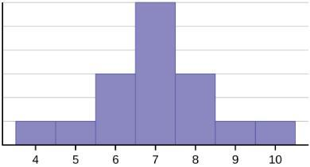

Data Skewed to the Left:
- The right-hand side seems "chopped off" compared to the left side.
- A distribution of this type is called skewed to the left because it is pulled out to the left.
- Notice that the mean is less than the median, and they are both less than the mode. The mean and the median both reflect the skewing, but the mean reflects it more so.
- To summarize, generally if the distribution of data is skewed to the left, the mean is less than the median, which is often less than the mode.
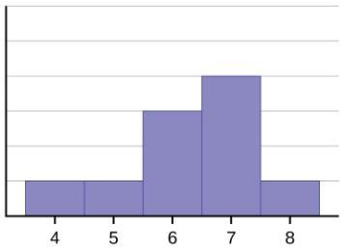
Data Skewed to the Right:
- A distribution of this type is called skewed to the right because it is pulled out to the right.
- Of the three statistics, the mean is the largest, while the mode is the smallest. Again, the mean reflects the skewing the most.
- To summarize, if the distribution of data is skewed to the right, the mode is often less than the median, which is less than the mean.
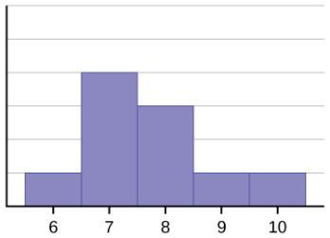

Which measure of center is affected by outliers?

When the distribution of data is skewed to the left, what does this indicate about the mean and median?

When the distribution of data is skewed to the right, what does this indicate about the mean and median?

Section 2.7: Measures of the Spread of the Data
Some notes about variation in data:
- An important characteristic of any set of data is the variation in the data.
- In some data sets, the data values are concentrated closely near the mean; in other data sets, the data values are more widely spread out from the mean.
- The most common measure of variation, or spread, is the standard deviation.
How do we define the standard deviation?

What values does the standard deviation take on?

What does the standard deviation mean if it is small or large?

Other notes on the standard deviation:
- The standard deviation can be used to determine whether a data value is close to or far from the mean.
- A data value that is two standard deviations from the average is just on the borderline for what many statisticians would consider to be far from the average.
- Considering data to be far from the mean if it is more than two standard deviations away is more of an approximate "rule of thumb" than a rigid rule.
- In general, the shape of the distribution of the data affects how much of the data is further away than two standard deviations. (You will learn more about this in later chapters.)

Notes on calculating the standard deviation:
- The procedure to calculate the standard deviation depends on whether the numbers are the entire population or are data from a sample.
- The calculations are similar, but not identical. Therefore the symbol used to represent the standard deviation depends on whether it is calculated from a population or a sample.
- The lower case letter s represents the sample standard deviation and the Greek letter σ (sigma, lower case) represents the population standard deviation.
- If the sample has the same characteristics as the population, then s should be a good estimate of σ.
- To calculate the standard deviation, we need to calculate the variance first.
- The variance is the average of the squares of the deviations
  - (the x – $\overline{x}$ values for a sample, or the x – μ values for a population)
State the notation for the following:
Population standard deviation: Population variance:

Sample standard deviation: Sample variance:

In this class, we will typically use which type of standard deviation? Why?

State the formula for the population standard deviation:

State the formula for the sample standard deviation:

What is the main difference between these two formulas?

Which formula will you use most often?

Example We will reference the Excel data file in this example. The ages are rounded to the nearest half year:
9; 9.5; 9.5; 10; 10; 10; 10; 10.5; 10.5; 10.5; 10.5; 11; 11; 11; 11; 11; 11; 11.5; 11.5; 11.5;
The variance may be calculated by using a table. Then the standard deviation is calculated by taking the square root of the variance.
Set up the table to perform the calculations. You do not have to write out a row for every single data point, but write out at least 5 rows to show the pattern of how the calculation works.

What is the formula in Excel that will do all this work for us? Explain how the formula works, and the value of the formula for the data above.

How can we use the standard deviation to compare data values?
- The standard deviation is useful when comparing data values that come from different data sets.
- If the data sets have different means and standard deviations, then comparing the data values directly can be misleading.
Explain an example of a situation where the standard deviation can be very useful in relation to the data set:

Explain what a z-score is an how to calculate it:

Example Two students, John and Ali, from different high schools, wanted to find out who had the highest GPA when compared to his school. Which student had the highest GPA when compared to his school?
- Student GPA School mean GPA School standard deviation
- John 2.85 3.0 0.7
- Ali 77 80 10

What is Chebyshev's Rule?

How does this rule change if we have normally distributed data?

