Chapter 3 Part 2 Notes
Section 3.3: Two Basic Rules of Probability
What is the multiplication rule?

If A and B are independent, what does this mean?

What is the addition rule?

If A and B are mutually exclusive, what does this mean?

Example Klaus is trying to choose where to go on vacation. His two choices are: A = New Zealand and B = Alaska. Klaus can only afford one vacation. The probability that he chooses A is P(A) = 0.6 and the probability that he chooses B is P(B) = 0.35.
P(A∩B)=0 because Klaus can only afford to take one vacation
What is the probability that he choose New Zealand or Alaska? Explain why.

What does the remaining probability mean?

Example Carlos plays college soccer. He makes a goal 65% of the time he shoots. Carlos is going to attempt two goals in a row in the next game. A = the event Carlos is successful on his first attempt. P(A) = 0.65. B = the event Carlos is successful on his second attempt. P(B) = 0.65. Carlos tends to shoot in streaks. The probability that he makes the second goal GIVEN that he made the first goal is 0.90.
- What is the probability that he makes both goals?

- What is the probability that Carlos makes either the first goal or the second goal?

- Are A and B independent?

- Are A and B mutually exclusive?

Example Felicity attends Modesto JC in Modesto, CA. The probability that Felicity enrolls in a math class is 0.2 and the probability that she enrolls in a speech class is 0.65. The probability that she enrolls in a math class GIVEN that she enrolls in speech class is 0.25.
Let: M = math class, S = speech class, M|S = math given speech
- What is the probability that Felicity enrolls in math and speech? Find P(M AND S) = P(M|S)P(S).

- What is the probability that Felicity enrolls in math or speech classes? Find P(M OR S) = P(M) + P(S) - P(M AND S).

- Are M and S independent? Is P(M|S) = P(M)?

- Are M and S mutually exclusive? Is P(M AND S) = 0?

Section 3.4: Contingency Tables
What is a contingency table?
- A contingency table provides a way of portraying data that can facilitate calculating probabilities.
- The table helps in determining conditional probabilities quite easily.
- The table displays sample values in relation to two different variables that may be dependent or contingent on one another.
Example Suppose a study of speeding violations and drivers who use cell phones produced the following fictional data:
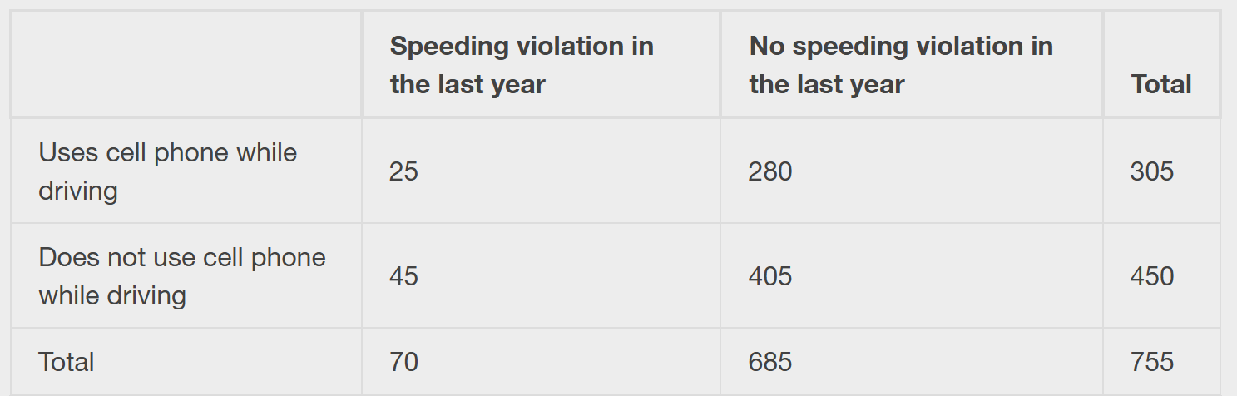
- a. Find P(Driver is a cell phone user).

- b. Find P(driver had no violation in the last year).

- c. Find P(Driver had no violation in the last year AND was a cell phone user).

Example Suppose a study of speeding violations and drivers who use cell phones produced the following fictional data:
- d. Find P(Driver is a cell phone user OR driver had no violation in the last year).

- e. Find P(Driver is a cell phone user GIVEN driver had a violation in the last year).

- f. Find P(Driver had no violation last year GIVEN driver was not a cell phone user)

Example Complete the contingency table. You can use the class Excel file and fill that in:
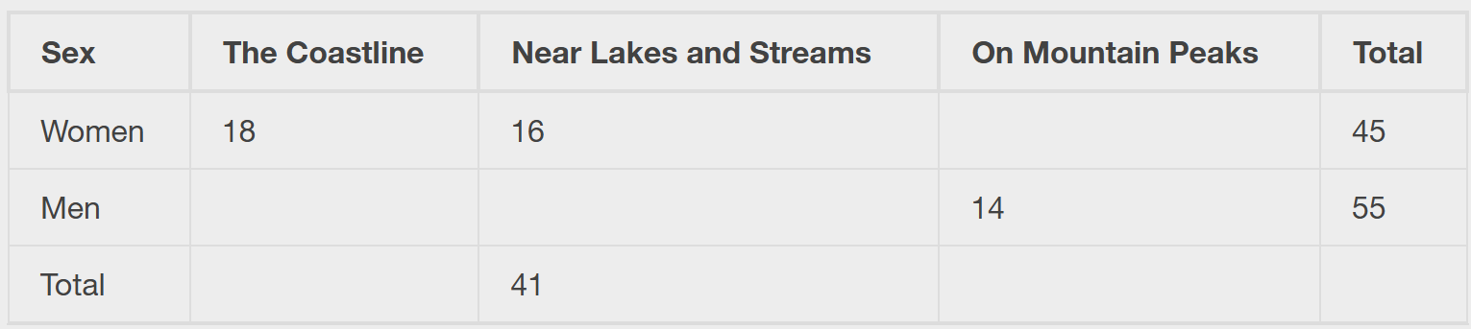
Are the events "being a woman" and "preferring the coastline" independent events?

Example Find the probability that a person is a woman or prefers hiking on mountain peaks. Let F = being a woman, and let P = prefers mountain peaks.
- Find P(F).  - Find P(P). | - Find P(F AND P).  - Find P(F OR P).
Section 3.5: Tree and Venn Diagrams
What is a tree diagram?
- A tree diagram is a special type of graph used to determine the outcomes of an experiment.
- It consists of "branches" that are labeled with either frequencies or probabilities.
- Tree diagrams can make some probability problems easier to visualize and solve.
Example In an urn, there are 11 balls. Three balls are red (R) and eight balls are blue (B). Draw two balls, one at a time, with replacement. "With replacement" means that you put the first ball back in the urn before you select the second ball. The tree diagram using frequencies that show all the possible outcomes follows. The first set of branches represents the first draw. The second set of branches represents the second draw. Each of the outcomes is distinct. In fact, we can list each red ball as R1, R2, and R3 and each blue ball as B1, B2, B3, B4, B5, B6, B7, and B8. Then the nine RR outcomes can be written as: R1R1; R1R2; R1R3; R2R1; R2R2; R2R3; R3R1; R3R2; R3R3.
The other outcomes are similar. There are a total of 11 balls in the urn. Draw two balls, one at a time, with replacement. There are 11(11) = 121 outcomes, the size of the sample space. (OR Total = 64 + 24 + 24 + 9 = 121).
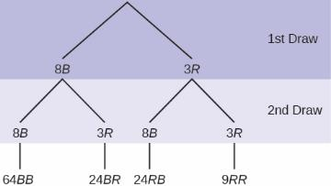
- Using the tree diagram, calculate P(RR).

- Using the tree diagram, calculate P(R on 1st draw and B on 2nd draw)

- Using the tree diagram, calculate P(BB).

What is a Venn diagram?
- A Venn diagram is a picture that represents the outcomes of an experiment.
- It generally consists of a box that represents the sample space S together with circles or ovals. The circles or ovals represent events.
Example Suppose an experiment has the outcomes 1, 2, 3, ... , 12 where each outcome has an equal chance of occurring.
- Let event A = {1, 2, 3, 4, 5, 6} and event B = {6, 7, 8, 9}.
- Then A AND B = {6} and A OR B = {1, 2, 3, 4, 5, 6, 7, 8, 9}.
- The Venn diagram is as follows:
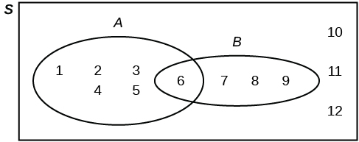
Example Flip two fair coins. Let A = tails on the first coin. Let B = tails on the second coin. Then A = {TT, TH} and B = {TT, HT}. Therefore, A∩B={TT}. A∪B={TH, TT, HT}
The sample space when you flip two fair coins is X = {HH, HT, TH, TT}. The outcome HH is in NEITHER A NOR B. The Venn diagram is as follows:
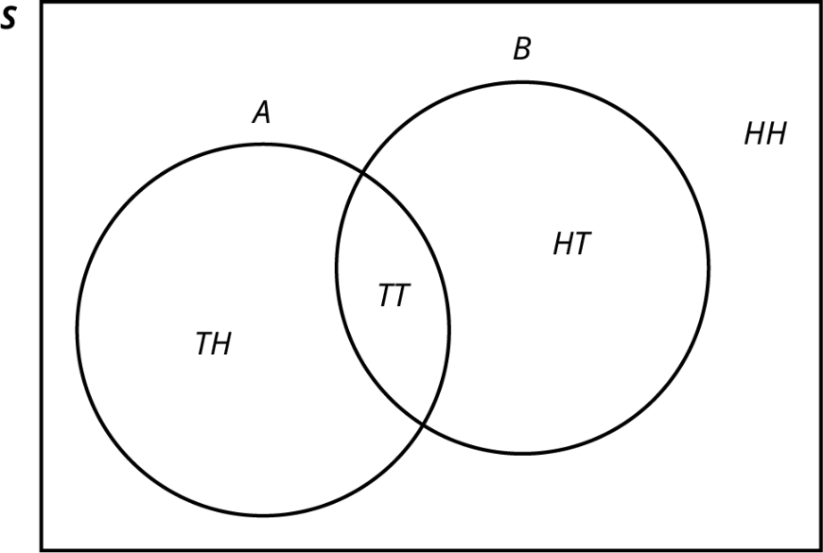

Example A person with type O blood and a negative Rh factor (Rh-) can donate blood to any person with any blood type. Four percent of African Americans have type O blood and a negative RH factor, 5−10% of African Americans have the Rh- factor, and 51% have type O blood.
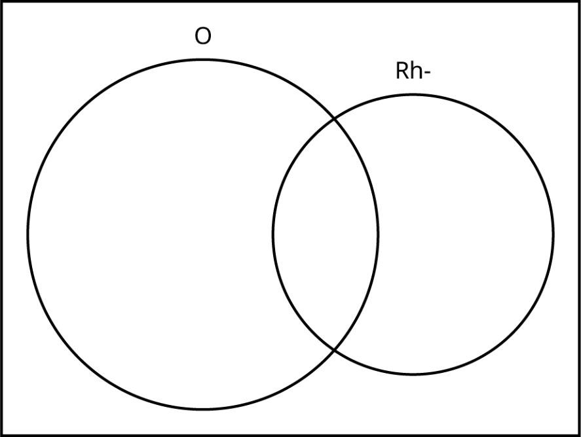
We will take the average of 5% and 10% and use 7.5% as the percent of African Americans who have the Rh- factor. Let O = African American with Type O blood and R = African American with Rh- factor. Find the following:
- P(O)

- P(R)

- P(O∩R)

- P(O∪R)

