Chapter 4 Part 1 Notes
Section 4.1: Probability Distribution Function (PDF) for a Discrete Random Variable
What is a random variable?

How do you denote a random variable?

What is the difference between capital X and lowercase x?

As an example, let X = the number of heads you get when you toss three fair coins. The sample space for the toss of three fair coins is TTT; THH; HTH; HHT; HTT; THT; TTH; HHH. Then, x = 0, 1, 2, 3. X is in words and x is a number. Show how we might display these outcomes in a table form.

What are the characteristics of a discrete probability distribution function?

A child psychologist is interested in the number of times a newborn baby's crying wakes its mother after midnight. For a random sample of 50 mothers, the following information was obtained. Let X = the number of times per week a newborn baby's crying wakes its mother after midnight. For this example, x = 0, 1, 2, 3, 4, 5.
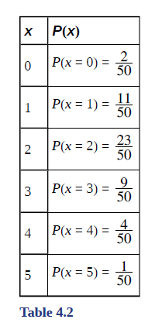 | P(x) = probability that X takes on a value x.  What values does X take on?  How can you tell this is discrete probability distribution function?

Example Suppose Nancy has classes three days a week. She attends classes three days a week 80% of the time, two days 15% of the time, one day 4% of the time, and no days 1% of the time. Suppose one week is randomly selected.
- Define: X =

- X takes on what values?

- Suppose one week is randomly chosen. Construct a probability distribution table (called a PDF table). The table should have two columns labeled x and P(x). What does the P(x) column sum to?

Section 4.2: Mean or Expected Value and Standard Deviation of a PDF
What is expected value?
- The expected value is often referred to as the "long-term" average or mean.
- This means that over the long term of doing an experiment over and over, you would expect this average.
- The Law of Large Numbers states that, as the number of trials in a probability experiment increases, the difference between the theoretical probability of an event and the relative frequency approaches zero (the theoretical probability and the relative frequency get closer and closer together).
- When evaluating the long-term results of statistical experiments, we often want to know the “average” outcome.
- This “long-term average” is known as the mean or expected value of the experiment and is denoted by the Greek letter μ.
- In other words, after conducting many trials of an experiment, you would expect this average value.
- NOTE: To find the expected value or long term average, μ, simply multiply each value of the random variable by its probability and add the products.
What is the notation for an expected value? What are other ways to refer to this?

Can we compute a mean from a PDF table?

State the formula for computing the expected value of a PDF:

State the formula for computing the standard deviation of a PDF:

Why are these formulas from what we discussed in chapter 2?

Let’s suppose we flip 2 coins and record the outcomes on each face, which would look like:
$$\{HH, HT, TH, TT\}$$
We are curious about the probability of getting at least 1 heads in the 2 flips.
Explain 2 ways to calculate this. Explain the difference between these methods.

Example A men's soccer team plays soccer zero, one, or two days a week. The probability that they play zero days is 0.2, the probability that they play one day is 0.5, and the probability that they play two days is 0.3. Find the long-term average or expected value, μ, of the number of days per week the men's soccer team plays soccer. To do the problem, first let the random variable X = the number of days the men's soccer team plays soccer per week. X takes on the values 0, 1, 2. Construct a PDF table adding a column x*P(x). Show how to find the expected value and standard deviation.

Example Suppose these are the probabilities for each outcome. Find the missing value:
x | P(x)
0 | 0.12
1 | 0.18
2 | 0.30
3 | 0.15
4
5 | 0.10
6 | 0.05

- What do the probabilities need to sum to?

- P(x = 4) =

- P(x ≥ 5) =

- On average, how long would you expect a new hire to stay with the company? (see Excel workbook)

- What is the standard deviation?

Example Find the expected value and standard deviation from the expected value table. See the Excel workbook.
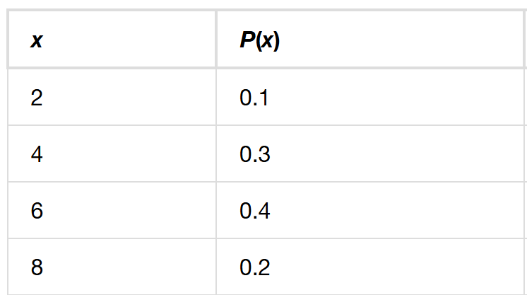

Example Suppose you play a game with a biased coin. You play each game by tossing the coin once. P(heads) = $\frac{2}{3}$ and P(tails) = $\frac{1}{3}$. If you toss a head, you pay $6. If you toss a tail, you win $10. If you play this game many times, will you come out ahead?
- Define a random variable X.

- Create a table of expected value outcomes. Create your own unique Excel spreadsheet.

- What is the expected value, μ? Do you come out ahead?

Example Toss a fair, six-sided die twice. Let X = the number of faces that show an even number. Construct a table of outcomes and calculate the mean μ and standard deviation σ of X. Create your own unique Excel spreadsheet.

