Exam 1 Review Assignment
Study Guide – You will want to practice these for the exam from the OpenStax text:
- From Chapter 1
  - Practice Section: 39
  - Homework Section: 42-65, 71-73, 80, 81, 85-88
- From Chapter 2
  - Practice Section: 1, 12-15, 23-27, 34-39, 42-48, 55-63, 71
  - Homework Section: 92, 94-98, 104
- From Chapter 3
  - Practice Section: 2-21, 40-53
  - Homework Section: 85, 87, 91, 97, 98, 99, 112, 113, 114, 115
- From Chapter 4
  - Practice Section: 1-12, 18-20, 23-27
  - Homework Section: 71, 73, 77, 83-87, 93

Chapter 1
OpenStax Homework
42 and 46: For each of the following eight exercises, identify: a. the population, b. the sample, c. the parameter, d. the statistic, e. the variable, and f. the data. Give examples where appropriate.
42: A fitness center is interested in the mean amount of time a client exercises in the center each week.

46: A politician is interested in the proportion of voters in their district who think the politician doing a good job.

56 and 58: For the following exercises, identify the type of data that would be used to describe a response (quantitative discrete, quantitative continuous, or qualitative), and give an example of the data.
56: time in line to buy groceries

58: most-watched television show

72: A study was done to determine the age, number of times per week, and the duration (amount of time) of residents using a local park in San Jose. The first house in the neighborhood around the park was selected randomly and then every eighth house in the neighborhood around the park was interviewed. The sampling method was:
- simple random
- systematic
- stratified
- cluster
73: Name the sampling method used in each of the following situations:
- A person in the airport is handing out questionnaires to travelers asking them to evaluate the airport’s service. The person does not ask travelers who are hurrying through the airport with their hands full of luggage but instead asks all travelers who are sitting near gates and not taking naps while they wait.

- A teacher wants to know if her students are doing homework, so they randomly select rows two and five and then call on all students in row two and all students in row five to present the solutions to homework problems to the class.

80: Fifty part-time students were asked how many courses they were taking this term. The (incomplete) results are shown below:
# of Courses |  | Frequency | Relative Frequency | Cumulative Relative Frequency
1 |  | 30 | 0.6
2 |  | 15
3
Table 1.34 Part-time Student Course Loads
- Fill in the blanks.
- What percent of students take exactly two courses?

- What percent of students take one or two courses?

88: An advertisement for Acme Investments displays the two graphs in Figure 1.14 to show the value of Acme’s product in comparison with the Other Guy’s product. Describe the potentially misleading visual effect of these comparison graphs. How can this be corrected?
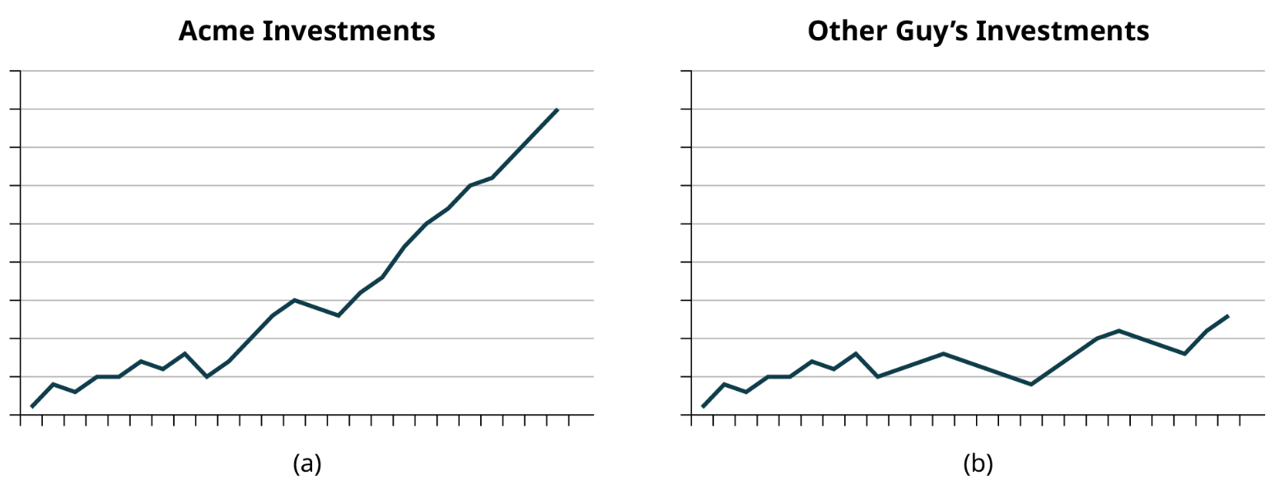

Chapter 2
23-24: Listed are 29 ages for Academy Award winning best actors in order from smallest to largest.
18; 21; 22; 25; 26; 27; 29; 30; 31; 33; 36; 37; 41; 42; 47; 52; 55; 57; 58; 62; 64; 67; 69; 71; 72; 73; 74; 76; 77
- Find the 78th percentile.

- Find percentile of 72.

#34-39: Sixty-five randomly selected car salespersons were asked the number of cars they generally sell in one week. Fourteen people answered that they generally sell three cars; nineteen generally sell four cars; twelve generally sell five cars; nine generally sell six cars; eleven generally sell seven cars.
34. First quartile =

35. Second quartile = median = 50th percentile =

36. Third quartile =

37. Interquartile range (IQR) =

38. 10th percentile =

42. Find the mean for the frequency table.
Grade | Frequency
49.5–59.5 | 2
59.5–69.5 | 3
69.5–79.5 | 8
79.5–89.5 | 12
89.5–99.5 | 5

55-57. Describe the shape of this distribution. Describe the relationship between the mode and the median of this distribution. Describe the relationship between the mean and the median of this distribution.
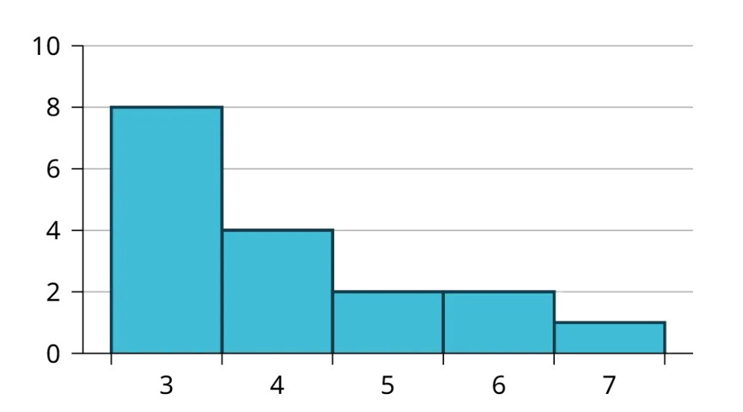

71. Two baseball players, Fredo and Karl, on different teams wanted to find out who had the higher batting average when compared to his team. Which baseball player had the higher batting average when compared to his team?
Baseball Player | Batting Average | Team Batting Average | Team Standard Deviation
Fredo | 0.158 | 0.166 | 0.012
Karl | 0.177 | 0.189 | 0.015

Find the 5-number summary, IQR, and box plot for the data in the Excel file.

Chapter 3
There are 23 countries in North America, 12 countries in South America, 47 countries in Europe, 44 countries in Asia, 54 countries in Africa, and 14 in Oceania (Pacific Ocean region).
Let A = the event that a country is in Asia.
Let E = the event that a country is in Europe.
Let F = the event that a country is in Africa.
Let N = the event that a country is in North America.
Let O = the event that a country is in Oceania.
Let S = the event that a country is in South America.
12. Find P(A).

14. Find P(F).

18. What is the probability of drawing a red card in a standard deck of 52 cards?

20. What is the probability of rolling an even number of dots with a fair, six-sided die numbered one through six?

40. E and F are mutually exclusive events. P(E) = 0.4; P(F) = 0.5. Find P(E∣F).

41. J and K are independent events. P(J|K) = 0.3. Find P(J).

A local restaurant knows that the probability that a customer will order a pizza is 87%. The restaurant also knows that the probability that a customer will order a salad is 32%. Of the customers who order pizzas, 55% of them also order a salad.
44. Find P(Z).

45. Find P(S).

46. Find P(S|Z).

48. Find 𝑃(𝑍 $∩$ 𝑆).

50. Are Z and S independent events? Show why or why not.

98. At a college, 72% of courses have final exams and 46% of courses require research papers. Suppose that 32% of courses have a research paper and a final exam. Let F be the event that a course has a final exam. Let R be the event that a course requires a research paper.
- Find the probability that a course has a final exam or a research project.

- Find the probability that a course has NEITHER of these two requirements.

112. The table identifies a group of children by one of four hair colors, and by type of hair.
Hair Type | Brown | Blond | Black | Red | Totals
Wavy | 20 |  | 15 | 3 | 43
Straight | 80 | 15 |  | 12
Totals |  | 20 |  |  | 215

Complete the table.
What is the probability that a randomly selected child will have wavy hair?

What is the probability that a randomly selected child will have red hair, given that they have straight hair?

If B is the event of a child having brown hair, find the probability of the complement of B.

This tree diagram shows the tossing of an unfair coin followed by drawing one bead from a cup containing three red (R), four yellow (Y) and five blue (B) beads. For the coin, P(H) = 23 and P(T) = 13 where H is heads and T is tails.
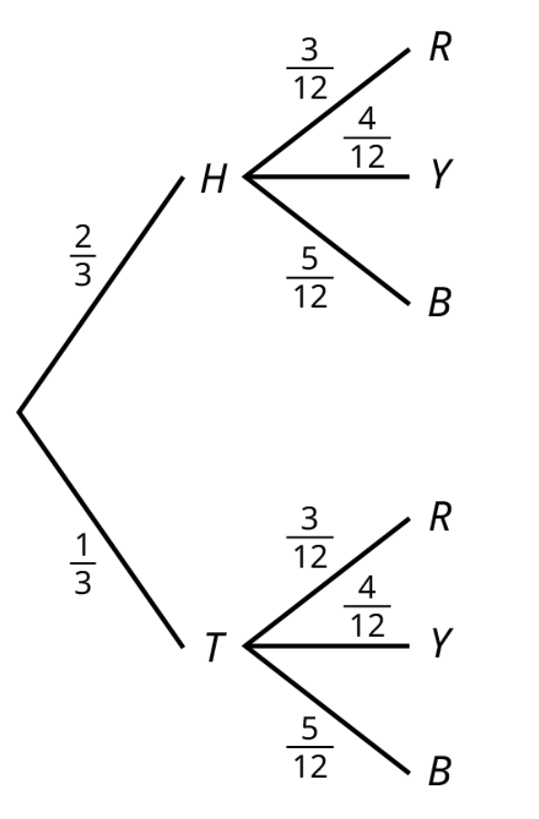
114. Find P(tossing a Head on the coin AND a Red bead)

Chapter 4
A baker is deciding how many batches of muffins to make to sell in his bakery. He wants to make enough to sell every one and no fewer. Through observation, the baker has established a probability distribution.
x | P(x)
1 | 0.15
2 | 0.35
3 | 0.40
4 | 0.10

6. Define the random variable X.

7. What is the probability the baker will sell more than one batch? P(x > 1) =

9. On average, how many batches should the baker make?

Find the mean and standard deviation of the PDF table.
x | P(x)
0 | 0.2
1 | 0.2
2 | 0.4
3 | 0.2

71. A game involves selecting a card from a regular 52-card deck and tossing a coin. The coin is a fair coin and is equally likely to land on heads or tails.
- If the card is a face card, and the coin lands on Heads, you win $6
- If the card is a face card, and the coin lands on Tails, you win $2
- If the card is not a face card, you lose $2, no matter what the coin shows.
Find the expected value for this game (expected net gain or loss).

Explain what your calculations indicate about your long-term average profits and losses on this game.

Should you play this game to win money?

Recently, a nurse commented that when a patient calls the medical advice line claiming to have the flu, the chance that they truly have the flu (and not just a nasty cold) is only about 4%. Of the next 25 patients calling in claiming to have the flu, we are interested in how many actually have the flu.
83. Define the random variable and list its possible values.

84. State the distribution of X.

85. Find the probability that at least four of the 25 patients actually have the flu.

86. On average, for every 25 patients calling in, how many do you expect to have the flu?

93. A student takes a 32-question multiple-choice exam, but did not study and randomly guesses each answer. Each question has three possible choices for the answer. Find the probability that the student guesses more than 75% of the questions correctly.

