Chapter 5 Part 1 Notes
Section 5.1: Continuous Probability Functions
Properties of Continuous Probability Distributions
- The graph of a continuous probability distribution is a curve. Probability is represented by area under the curve.
- The curve is called the probability density function (abbreviated as pdf). We use the symbol f(x) to represent the curve. f(x) is the function that corresponds to the graph; we use the density function f(x) to draw the graph of the probability distribution.
- Area under the curve is given by a different function called the cumulative distribution function (abbreviated as cdf). The cumulative distribution function is used to evaluate probability as area.
How are outcomes determined in a continuous probability function?

What is the area under curve equal to?

How does probability computed? How is this different from a discrete probability function?

What does $P(x=c)$ equal? Why?

Explain the difference between $P(c<x<d)$ versus $P\left(c≤x≤d\right)?$

More Properties of Continuous Probability Distributions
- We will find the area that represents probability by using geometry, formulas, technology, or probability tables.
- Since the maximum probability is one, the maximum area is also one. For continuous probability distributions, PROBABILITY = AREA.
- There are many continuous probability distributions. When using a continuous probability distribution to model probability, the distribution used is selected to model and fit the particular situation in the best way. A few common ones are:
  - Uniform Distribution
  - Exponential Distribution
  - Normal Distribution
Draw some examples of the different types of distributions:

Explain the differences between discrete and continuous probability distributions:

Example What does the shaded area represent?
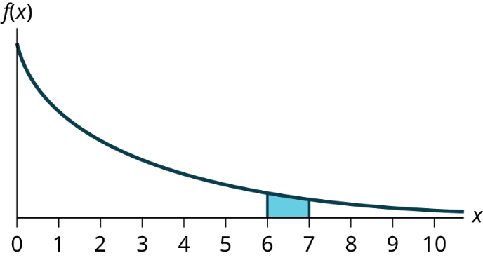

Example For a continuous probability distribution, 0 ≤ x ≤ 10. What is P(x = 7)?
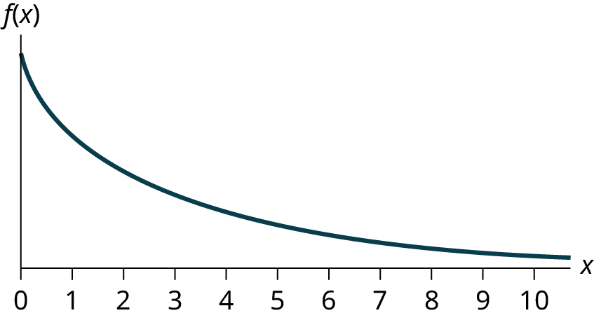

Example Find the probability that x falls in the shaded area.
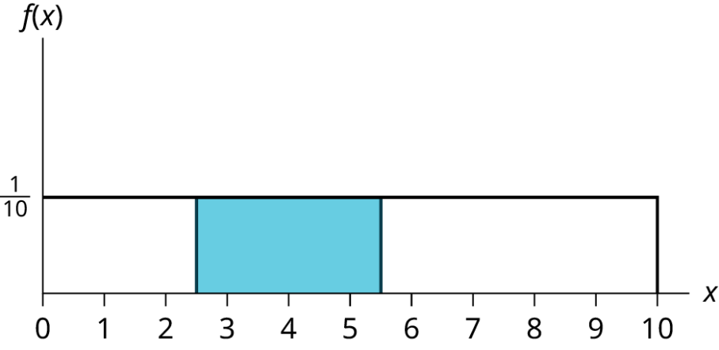

Section 5.2: The Uniform Distribution
About the Uniform Distrubtion:
- The uniform distribution is a continuous probability distribution and is concerned with events that are equally likely to occur.
- When working out problems that have a uniform distribution, be careful to note if the data is inclusive or exclusive of endpoints.
How do you calculate the equation for a uniform distribution?

What are the theoretical mean and standard deviation of this distribution?

Example Find the sample mean and standard deviation of the data. Suppose we know that this data is uniformly distributed. We will assume that the smiling times, in seconds, follow a uniform distribution between zero and 23 seconds, inclusive. This means that any smiling time from zero to and including 23 seconds is equally likely. The histogram that could be constructed from the sample is an empirical distribution that closely matches the theoretical uniform distribution. Find the theoretical mean and standard deviation of the uniform distribution.
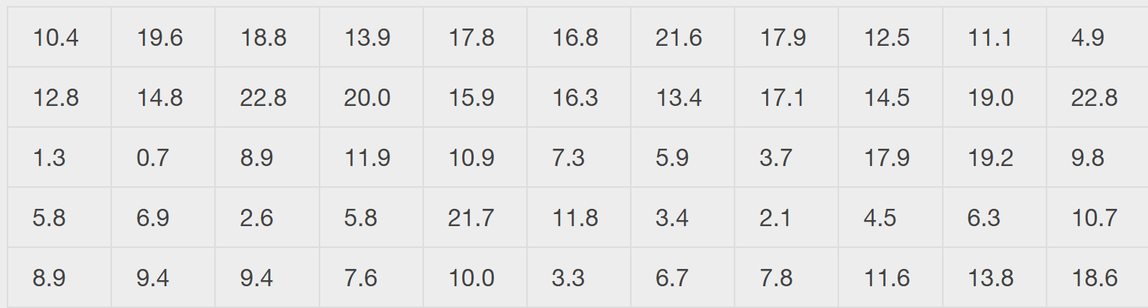

Example The amount of time, in minutes, that a person must wait for a bus is uniformly distributed between zero and 15 minutes, inclusive.
What is the probability that a person waits fewer than 12.5 minutes?

On the average, how long must a person wait? Find the mean, μ, and the standard deviation, σ.

Ninety percent of the time, the time a person must wait falls below what value?

Example Ace Heating and Air Conditioning Service finds that the amount of time a repair tech needs to fix a furnace is uniformly distributed between 1.5 and four hours. Let x = the time needed to fix a furnace. Then x ~ U (1.5, 4).
Find the probability that a randomly selected furnace repair requires more than two hours.

Find the probability that a randomly selected furnace repair requires less than three hours.

Find the 30th percentile of furnace repair times.

The longest 25% of furnace repair times take at least how long? (In other words: find the minimum time for the longest 25% of repair times.) What percentile does this represent?

Find the mean and standard deviation

