Chapter 6 Part 2 Notes
Section 6.2: Using the Normal Distribution
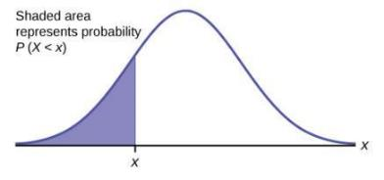 | Using the Normal Distribution:  - The shaded area in the following graph indicates the area to the left of x. This area is represented by the probability P(X < x).  - P(X < x) = Area to the left of the vertical line through x.  - P(X < x) is the same as P(X ≤ x) for continuous distributions.  - Calculators are used to calculate the probability P(X < x).  - We can use Excel instead of a calculator.

Which direction does Excel always calculate area?

How do you calculate area to the right, ie how do you calculate $P\left(X>x\right)?$

What is the difference between $P(X>x)$ and $P(X≥x)$? Why?

Example If the area to the left of x is 0.0228, what is the area to the right?

Calculating Probabilities:
- To find the probability for probability density functions with a continuous random variable we need to calculate the area under the function across the values of X we are interested in.
- The true calculation of these probabilities would require complex formulas and integral calculus.
- However, since the normal distribution is so heavily used in statistics, we can just use Excel formulas. We can also transform our data from the normal distribution to the standard normal distribution.
- We can transform our distribution using the standard formula: $Z=\frac{x-μ}{σ}$
Explain how the normal and standard normal distributions are related:

Example The final exam scores in a statistics class were normally distributed with a mean of 63 and a standard deviation of five. Refer to the Excel spreadsheet for hints on how to do the computations for this problem.
- Find the probability that a randomly selected student scored more than 65 on the exam. Compare these results for both the normal and standard normal distributions. Draw the curve for each of these situations.

b. Find the probability that a randomly selected student scored less than 85. Compare these results for both the normal and standard normal distributions. Draw the curve for each of these situations.

Example A personal computer is used for office work at home, research, communication, personal finances, education, entertainment, social networking, and a myriad of other things. Suppose that the average number of hours a household personal computer is used for entertainment is two hours per day. Assume the times for entertainment are normally distributed and the standard deviation for the times is half an hour.
- Find the probability that a household personal computer is used for entertainment between 1.8 and 2.75 hours per day. Draw the curve(s) associated with this situation.

- Find the maximum number of hours per day that the bottom quartile of households uses a personal computer for entertainment. Draw the curve(s) associated with this situation.

Example In the United States the ages 13 to 55+ of smartphone users approximately follow a normal distribution with approximate mean and standard deviation of 36.9 years and 13.9 years, respectively.
- Determine the probability that a random smartphone user in the age range 13 to 55+ is between 23 and 64.7 years old.

- Determine the probability that a randomly selected smartphone user in the age range 13 to 55+ is at most 50.8 years old.

- Calculate the interquartile range (IQR).

- Forty percent of the smartphone users from 13 to 55+ are at least what age?

Additional Section: Estimating the Binomial Distribution with the Normal Distribution
The Binomial Process can be estimated with the Normal Distribution
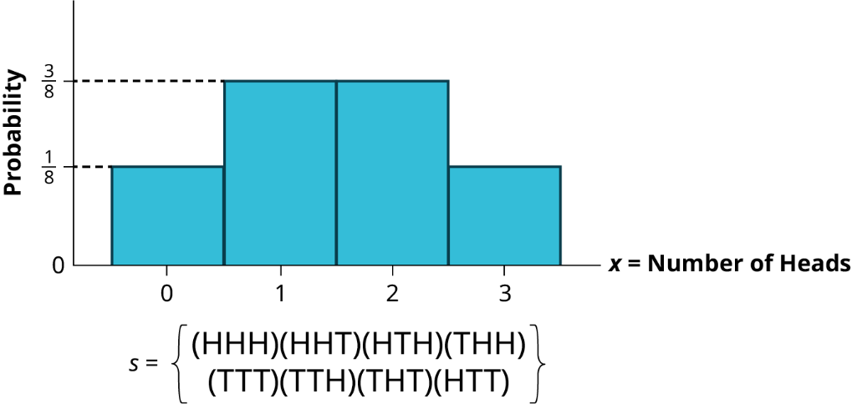 | - We found earlier that various probability density functions are the limiting distributions of others; thus, we can estimate one with another under certain circumstances.  - We will find here that the normal distribution can be used to estimate a binomial process. Draw how a normal distribution can fit on the binomial distribution to the left.
Some Binomial Processes are Skewed
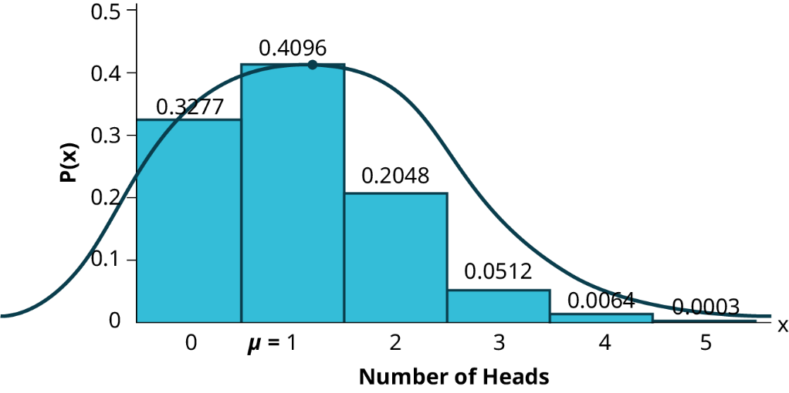 | - The reason the skewness of the binomial distribution is important is because if it is to be estimated with a normal distribution, then we need to recognize that the normal distribution is symmetrical. In the example below, we used a coin that did not have 50/50 odds.  - The closer the underlying binomial distribution is to being symmetrical, the better the estimate that is produced by the normal distribution.

What are the criteria for a normal distribution to estimate a binomial distribution?

Example Imagine that it is known that only 10% of Australian Shepherd puppies are born with what is called "perfect symmetry" in their three colors, black, white, and copper. Perfect symmetry is defined as equal coverage on all parts of the dog when looked at in the face and measuring left and right down the centerline. A kennel would have a good reputation for breeding Australian Shepherds if they had a high percentage of dogs that met this criterion. During the past 5 years and out of the 100 dogs born to Dundee Kennels, 16 were born with this coloring characteristic.
What is the probability that, in 100 births, more than 16 would have this characteristic?
First do this using a binomial distribution:

Now do the same problem with a normal distribution:

Example An experiment with a probability of success given as 0.40 is repeated 100 times. Use the normal distribution to approximate the binomial distribution, and find the probability the experiment will have from 35 to 45 successes.
First do this using a binomial distribution:

Now do the same problem with a normal distribution:

Example Historically, a final exam in a course is passed with a probability of 0.9. The exam is given to a group of 70 students. What is the probability that at least 65 of them passed?

Example A tree in an orchard has 200 oranges. Of the oranges, 40 are not ripe. Use the normal distribution to approximate the binomial distribution, and determine the probability a box containing 35 oranges has at most two oranges that are not ripe.

Putting It All Together
Review
- A fair coin is flipped 2 times. What is the probability of getting a heads first in this situation?

- In a large city one in ten fire hydrants are in need of repair. If a crew examines 100 fire hydrants in a week, what is the probability they will find nine of fewer fire hydrants that need repair? Use the normal distribution to approximate the binomial distribution.

- You buy a lottery ticket to a lottery that costs $10 per ticket. There are only 100 tickets available to be sold in this lottery. In this lottery there are one $500 prize, two $100 prizes, and four $25 prizes. Find your expected gain or loss.

- Suppose that the duration of a particular type of criminal trial is known to be normally distributed with a mean of 21 days and a standard deviation of seven days. Sixty percent of all trials of this type are completed within how many days?

- Find the mean and standard deviation from a sample consisting of the amount of money spent on groceries in a single trip: $25.12, $82.12, $123.23, $75.23, $88.12, $105.27, $65.45, $49.23. What percentage of grocery bills in this sample were less than $75?

- A subway train arrives every eight minutes during rush hour. We are interested in the length of time a commuter must wait for a train to arrive. The time follows a uniform distribution. Find the mean and standard deviation. What is the probability that a commuter waits more than 5 minutes for the train?

