Chapter 9 Part 2 Notes
Section 9.4: Rare Events
- The occurrence of rare events can cause you to doubt any prior hypothesis.
- Suppose you make an assumption about a property of the population (this assumption is the null hypothesis). Then you gather sample data randomly. If the sample has properties that would be very unlikely to occur if the assumption is true, then you would conclude that your assumption about the population is probably incorrect.
  - You read that the average height at a college of 5’7” (this is your null). You survey the basketball team only and find that the average height in your sample of 6’6”. Is this a rare event or was your initial null hypothesis wrong?
- Hypothesis testing allows us to determine whether our data is a rare event or if we had made a wrong prior conjecture about data.
Example of a Rare Event The probability of winning the lottery is very low. Suppose Arianna played the lottery just once and won a lot of money. Because Ari assumed the probability of winning the lottery is low, Arianna hopes that her assumption is incorrect and hopes that it is indeed easy to win the lottery.
Ari winning the lottery is a rare event.
Testing the Null Hypothesis
- Use the sample data to calculate the actual probability of getting the test result, called the p-value. Define the p-value:

Using the p-Value
- This decision rule can be developed by calculating the probability that a sample mean could be found that would give a test statistic larger than the test statistic found from the current sample data assuming that the null hypothesis is true.
- The p-value approach compares the desired significance level, α, to the p-value which is the probability of drawing a sample mean further from the hypothesized value than the actual sample mean.
  - A large p-value calculated from the data indicates that we should not reject the null hypothesis. In other words, if $p≥α,$what would we do?

  - The smaller the p-value, the more unlikely the outcome, and the stronger the evidence is against the null hypothesis. We would reject the null hypothesis if the evidence is strongly against it. In other words, if $p<α,$ what would we do?

Values the Hypothesis Test with the P-value Approach
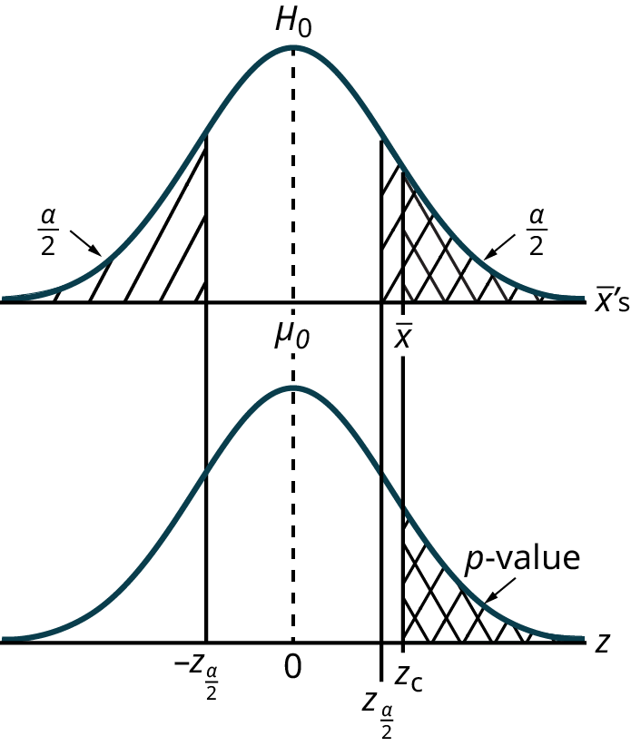 | - The calculated value of the test statistic is $z_{c}$ in this example and is marked on the bottom graph of the standard normal distribution because it is a z value.  - In this case the calculated value is in the tail and thus we cannot accept the null hypothesis, the associated $\overline{x}$is just too unusually large to believe that it came from the distribution with a mean of $µ_{0}$ with a significance level of α.  - If we use the p-value decision rule we need one more step. We need to find in the standard normal table the probability associated with the calculated test statistic, $z_{c}$. We then compare that to the α associated with our selected level of confidence.

P-Value Decision and Conclusion
- A systematic way to make a decision of whether to reject or not reject the null hypothesis is to compare the p-value and a preset or preconceived α (also called a "significance level").
- When you make a decision to reject or not reject $H_{0}$, do as follows:
  - If p-value < α, reject $H_{0}$. The results of the sample data are significant. There is sufficient evidence to conclude that $H_{0}$ is an incorrect belief and that the alternative hypothesis, $H_{A}$, may be correct.
  - If p-value ≥ α, do not reject $H_{0}$. The results of the sample data are not significant. There is not sufficient evidence to conclude that the alternative hypothesis, $H_{A}$, may be correct.
- When you "do not reject $H_{0}$", it does not mean that you should believe that $H_{0}$ is true. It simply means that the sample data have failed to provide sufficient evidence to cast serious doubt about the truthfulness of $H_{0}$.
- What is the helpful memory device regarding the p-value?

An Example Overview of the Hypothesis Test
Suppose a baker claims that his bread height is more than 15 cm, on average. Several of his customers do not believe him. To persuade his customers that he is right, the baker decides to do a hypothesis test. He bakes 10 loaves of bread. The mean height of the sample loaves is 17 cm. The baker knows from baking hundreds of loaves of bread that the standard deviation for the height is 0.5 cm. and the distribution of heights is normal.
The null hypothesis could be $H_{0}:μ≤15$ and the alternative hypothesis could be $H_{A}:μ>15$. In symbols, we would just state this as:
$$H_{0}:μ≤15$$
$$H_{A}:μ>15$$
We are using the Central Limit Theorem here, so for a sample of 10 loaves we will have:
  - Mean: $μ=15$
  - Standard deviation: $\frac{σ}{\sqrt{n}}=\frac{0.5}{\sqrt{10}}=0.16$
  - So $\overline{X}\sim N(15, 0.16)$
Suppose the null hypothesis is true (the mean height of the loaves is no more than 15 cm). Then is the mean height (17 cm) calculated from the sample unexpectedly large? The hypothesis test works by asking the question how unlikely the sample mean would be if the null hypothesis were true. The graph shows how far out the sample mean is on the normal curve. The p-value is the probability that, if we were to take other samples, any other sample mean would fall at least as far out as 17 cm.
The p-value, then, is the probability that a sample mean is the same or greater than 17 cm. when the population mean is, in fact, 15 cm. We can calculate this probability using the normal distribution for means.
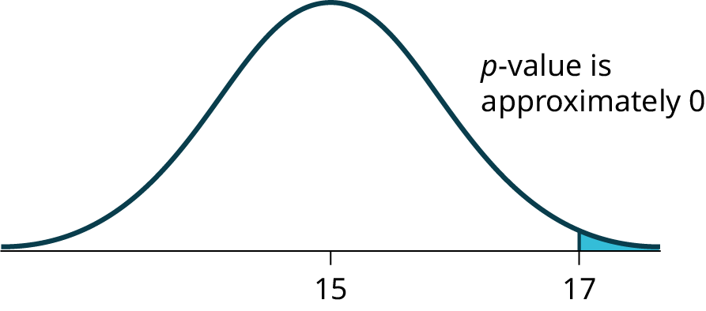
A p-value of approximately zero tells us that it is highly unlikely that a loaf of bread rises no more than 15 cm, on average. That is, almost 0% of all loaves of bread would be at least as high as 17 cm. purely by CHANCE had the population mean height really been 15 cm. Because the outcome of 17 cm. is so unlikely (meaning it is happening NOT by chance alone), we conclude that the evidence is strongly against the null hypothesis (the mean height is at most 15 cm.). There is sufficient evidence that the true mean height for the population of the baker's loaves of bread is greater than 15 cm.
Refer to the Excel workbook for how to calculate this situation with Excel.

Section 9.5: Additional Information and Full Hypothesis Test Examples
General Notes
- Remember, a decision of whether to reject or not reject the null hypothesis is to compare the p-value and a preset or preconceived α (also called a "significance level").
- In a hypothesis test problem, you may see words such as "the level of significance is 1%." The "1%" is the preconceived or preset α.
- The statistician setting up the hypothesis test selects the value of α to use before collecting the sample data. If no level of significance is given, a common standard to use is α = 0.05.
- When you calculate the p-value and draw the picture, the p-value is the area in the left tail, the right tail, or split evenly between the two tails. For this reason, we call the hypothesis test left, right, or two tailed.
- The alternative hypothesis, $H_{a}$ , tells you if the test is left, right, or two-tailed. It is the key to conducting the appropriate test.
The Basic Setup
- Determine your hypotheses.
- Determine your $α:$ if none is given, assume $α=0.05$.
- Organize your data. Remember, there is a difference between the given data versus what will be used for the sample distribution of means. Compute the test statistic.
- Compute your p-value using your sample distribution of means data using your test statistic and the appropriate distribution.
- Note: if you are using p-values, two-tailed p-values need to be multiplied by 2.
- Make your conclusion regarding the p-value (or critical values).
    - If p-value < α, reject $H_{0}$. The results of the sample data are significant. There is sufficient evidence to conclude that $H_{0}$ is an incorrect belief and that the alternative hypothesis,$H_{A}$, may be correct. P is low -> null must go.
    - If p-value ≥ α, do not reject $H_{0}$. The results of the sample data are not significant. There is not sufficient evidence to conclude that the alternative hypothesis, $H_{A}$, may be correct
- State the conclusion, both in formal statistical terms and in the context of the problem.

Common Ways to Organize Information for the Hypothesis Test
- State the hypotheses in symbols
- In words, CLEARLY state what your random variable represents with a sentence.
- State the distribution to use for the test.
- What is the test statistic?
- What is the p-value? In one or two complete sentences, explain what the p-value means for this problem.
- Use the previous information to sketch a picture of this situation. CLEARLY, label and scale the horizontal axis and shade the region(s) corresponding to the p-value.
- Indicate the correct decision (“reject” or “do not reject” the null hypothesis), the reason for it, and write an appropriate conclusion, using complete sentences.
  - Alpha: _______
  - Decision: _______
  - Reason for decision: _______
  - Conclusion: _______
Example H_{o}: μ = 5, H_{a}: μ < 5
Test of a single population mean. H_{a} tells you the test is left-tailed. The picture of the p-value is as follows:
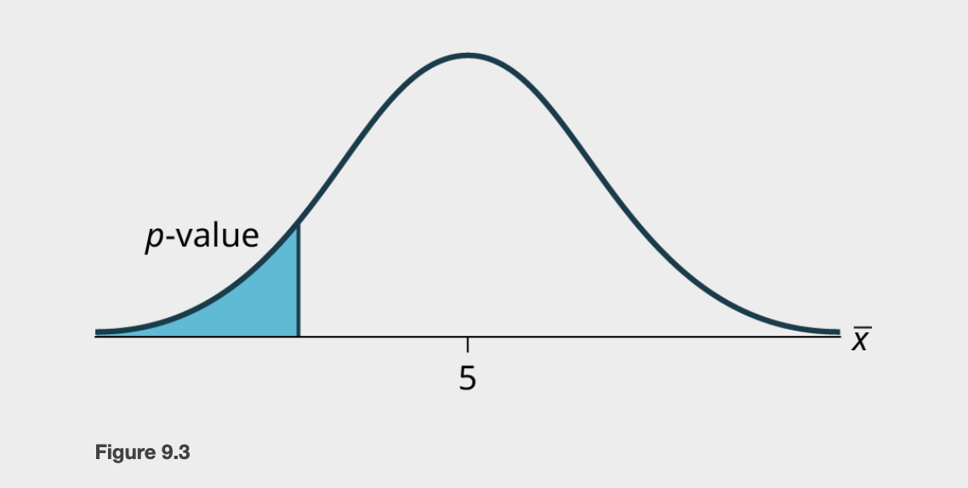
Example H₀: p = 50, H_{a}: p ≠ 50
This is a test of a single population mean. H_{a} tells you the test is two-tailed. The picture of the p-value is as follows. In this case, we need to multiply the p-value by 2 to represent the area in the end of both tails.
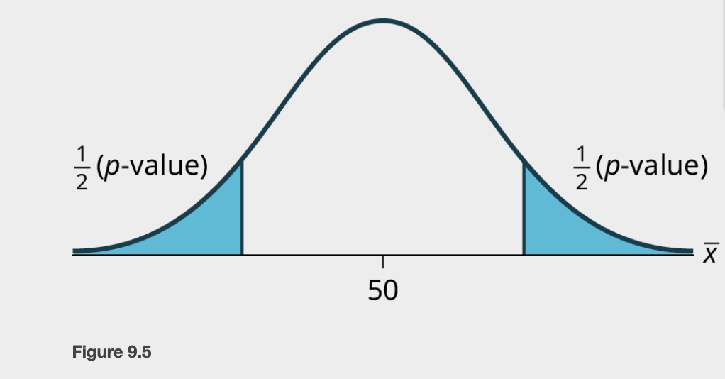

Example Jeffrey, as an eight-year old, established a mean time of 16.43 seconds for swimming the 25-yard freestyle, with a standard deviation of 0.8 seconds. His dad, Frank, thought that Jeffrey could swim the 25-yard freestyle faster using goggles. Frank bought Jeffrey a new pair of expensive goggles and timed Jeffrey for 15 25-yard freestyle swims. For the 15 swims, Jeffrey's mean time was 16 seconds. Frank thought that the goggles helped Jeffrey to swim faster than the 16.43 seconds. Conduct a hypothesis test using a preset α = 0.05. Assume that the swim times for the 25-yard freestyle are normal. Use

Example Jasmine has just begun her new job on the sales force of a very competitive company. In a sample of 16 sales calls it was found that she closed the contract for an average value of 108 dollars with a standard deviation of 12 dollars. Company policy requires that new members of the sales force must exceed an average of $100 per contract during the trial employment period. Can we conclude that Jasmine has met this requirement at the significance level of 95%?

Example A manufacturer of salad dressings uses machines to dispense liquid ingredients into bottles that move along a filling line. The machine that dispenses salad dressings is working properly when 8 ounces are dispensed. Suppose that the average amount dispensed in a particular sample of 35 bottles is 7.91 ounces with a variance of 0.03 ounces squared, $s^{2}$. Is there evidence that the machine should be stopped and production wait for repairs? The lost production from a shutdown is potentially so great that management feels that the level of significance in the analysis should be 99%. Again we will follow the steps in our analysis of this problem.

Example Statistics students believe that the mean score on the first statistics test is 65. A statistics instructor thinks the mean score is higher than 65. He samples ten statistics students and obtains the scores 65; 65; 70; 67; 66; 63; 63; 68; 72; 71. He performs a hypothesis test using a 5% level of significance. The data are assumed to be from a normal distribution. Use p-values.

Hypothesis Test for Proportions
- Just as there were confidence intervals for proportions, or more formally, the population parameter p of the binomial distribution, there is the ability to test hypotheses concerning p.
- The population parameter for the binomial is p. The estimated value (point estimate) for p is p′ where p′ = $\frac{x}{n}$, x is the number of successes in the sample and n is the sample size.
- When you perform a hypothesis test of a population proportion p, you take a simple random sample from the population. The conditions for a binomial distribution must be met, which are:
  - There are a certain number n of independent trials meaning random sampling, the outcomes of any trial are binary, success or failure, and each trial has the same probability of a success p.
  - The shape of the binomial distribution needs to be similar to the shape of the normal distribution. To ensure this, the quantities np′ and nq′ must both be greater than five (np′ > 5 and nq′ > 5). In this case the binomial distribution of a sample (estimated) proportion can be approximated by the normal distribution with μ=np and σ=$\sqrt{npq}$ . Remember that q=1–p.
  - There is no distribution that can correct for this small sample bias and thus if these conditions are not met we simply cannot test the hypothesis with the data available at that time.
What is the test statistic for proportions?

What are the forms of a hypothesis test with proportions?

Example Joon believes that 50% of first-time brides in the United States are younger than their grooms. She performs a hypothesis test to determine if the percentage is the same or different from 50%. Joon samples 100 first-time brides and 53 reply that they are younger than their grooms. For the hypothesis test, she uses a 1% level of significance.

Example Statistical data indicates that in a certain country there are approximately 268,608,618 residents aged 12 and older. For a certain period of time, statistical data also indicates that the percentage of residents with blood type AB negative (AB-) is 207,754 individuals. This translates into a percentage of 0.078% with this rather rare blood type. In a certain province of the country, there were 11 people with blood type AB- out of the population of 37,937. Conduct an appropriate hypothesis test to determine if there is a statistically significant difference between the percentage of residents in the entire country with blood type AB- versus the percentage in the local province. Use a significance level of 0.01.

