Chapter 12 Part 2 Notes
Section 12:4 Testing the Significance of the Correlation Coefficient
- We perform a hypothesis test of the "significance of the correlation coefficient" to decide whether the linear relationship in the sample data is strong enough to use to model the relationship in the population.
- The symbol for the population correlation coefficient is ρ, the Greek letter "rho."
  - ρ = population correlation coefficient (unknown)
  - r = sample correlation coefficient (known; calculated from sample data)
- The hypothesis test lets us decide whether the value of the population correlation coefficient ρ is "close to zero" or "significantly different from zero". We decide this based on the sample correlation coefficient r and the sample size n.
- What is the form of the hypotheses?

- WHAT THE HYPOTHESES MEAN IN WORDS:
  - Null Hypothesis Ho: The population correlation coefficient IS NOT significantly different from zero. There IS NOT a significant linear relationship(correlation) between x and y in the population.
  - Alternate Hypothesis Ha: The population correlation coefficient IS significantly DIFFERENT FROM zero. There IS A SIGNIFICANT LINEAR RELATIONSHIP (correlation) between x and y in the population.
Note:
  - If r is significant and the scatter plot shows a linear trend, the line can be used to predict the value of y for values of x that are within the domain of observed x values.
  - If r is not significant OR if the scatter plot does not show a linear trend, the line should not be used for prediction.
  - If r is significant and if the scatter plot shows a linear trend, the line may NOT be appropriate or reliable for prediction OUTSIDE the domain of observed x values in the data.

DRAWING A CONCLUSION:
- There are two methods of making the decision. The two methods are equivalent and give the same result.
  - Method 1: Using the p-value
  - Method 2: Using a table of critical values
- In this chapter of this textbook, we will always use a significance level of 5%, α = 0.05
- You can use Excel to calculate a p-value easily from your data
- Note: Using the p-value method, you could choose any appropriate significance level you want; you are not limited to using α = 0.05. But the table of critical values provided in this textbook assumes that we are using a significance level of 5%, α = 0.05. (If we wanted to use a different significance level than 5% with the critical value method, we would need different tables of critical values that are not provided in this textbook.)
There are two methods of making the decision concerning the hypothesis. The test statistic to test this hypothesis is:

What is the shorthand way to quickly test the correlation coefficient?

Example Using the data from the third exam versus the final, determine the significance of the correlation coefficient.
The line of best fit is: ŷ = -173.51 + 4.83x with r = 0.6631 and there are n = 11 data points.
Can the regression line be used for prediction? Given a third exam score (x value), can we use the line to predict the final exam score (predicted y value)?
Write down any relevant notes about using Excel for this exercise!

Misuse of Correlation Coefficients
- Correlations may be helpful in visualizing the data, but are not appropriately used to "explain" a relationship between two variables.
- Perhaps no single statistic is more misused than the correlation coefficient. Citing correlations between health conditions and everything from place of residence to eye color have the effect of implying a cause and effect relationship.
- The correlation coefficient is, of course, innocent of this misinterpretation. It is the duty of the analyst to use a statistic that is designed to test for cause and effect relationships and report only those results if they are intending to make such a claim.
- The problem is that passing this more rigorous test is difficult so lazy and/or unscrupulous "researchers" fall back on correlations when they cannot make their case legitimately.

Examples
- Suppose you computed r = –0.624 with 14 data points. df = 14 – 2 = 12. The critical values are –0.532 and 0.532. Since –0.624 < –0.532, r is significant and the line can be used for prediction.
- Suppose you computed r = 0.776 and n = 6. df = 6 – 2 = 4. The critical values are –0.811 and 0.811. Since –0.811 < 0.776 < 0.811, r is not significant, and the line should not be used for prediction.
Example
Consider the third exam / final exam example from earlier. The line of best fit is: ŷ = –173.51+4.83x with r = 0.6631 and there are n = 11 data points. Can the regression line be used for prediction? Given a third-exam score (x value), can we use the line to predict the final exam score (predicted y value)?

A Few More Examples
Suppose you computed the following correlation coefficients.
- r = –0.567 and the sample size, n, is 19. The df = n – 2 = 17. The critical value is –0.456. –0.567 < –0.456 so r is significant.
- r = 0.708 and the sample size, n, is nine. The df = n – 2 = 7. The critical value is 0.666. 0.708 > 0.666 so r is significant.
- r = 0.134 and the sample size, n, is 14. The df = 14 – 2 = 12. The critical value is 0.532. 0.134 is between –0.532 and 0.532 so r is not significant.
- r = 0 and the sample size, n, is five. No matter what the dfs are, r = 0 is between the two critical values so r is not significant.

Sections 12.5 and 12.6: Prediction and Outliers
- In some data sets, there are values (observed data points) called outliers.
- Outliers are observed data points that are far from the least squares line.
- It is possible that an outlier is a result of erroneous data. Other times, an outlier may hold valuable information about the population under study and should remain included in the data.
- The key is to examine carefully what causes a data point to be an outlier.
- We could guess at outliers by looking at a graph of the scatterplot and best fit-line. However, we would like some guideline as to how far away a point needs to be in order to be considered an outlier.
- What is a good rule of thumb for identifying outliers?

- The standard deviation used is the standard deviation of the residuals or errors.
- We can do this visually in the scatter plot by drawing an extra pair of lines that are two standard deviations above and below the best-fit line.
- Any data points that are outside this extra pair of lines are flagged as potential outliers.
How does the outlier affect the best fit line?
- If we were to measure the vertical distance from any data point to the corresponding point on the line of best fit and that distance is at least 2s, then we would consider the data point to be "too far" from the line of best fit.
- We need to find and graph the lines that are two standard deviations below and above the regression line. Any point that is outside these two lines are a potential outlier.
- Note: When outliers are deleted, the researcher should either record that data was deleted, and why, or the researcher should provide results both with and without the deleted data. If data is erroneous and the correct values are known (e.g., student one actually scored a 70 instead of a 65), then this correction can be made to the data.

Example A random sample of 11 statistics students produced the following data, where x is the third exam score out of 80, and y is the final exam score out of 200. Prove that this data set has at least 1 outlier. Create a table that compares the output of the regression to the actual values and determine if any other outliers exist.
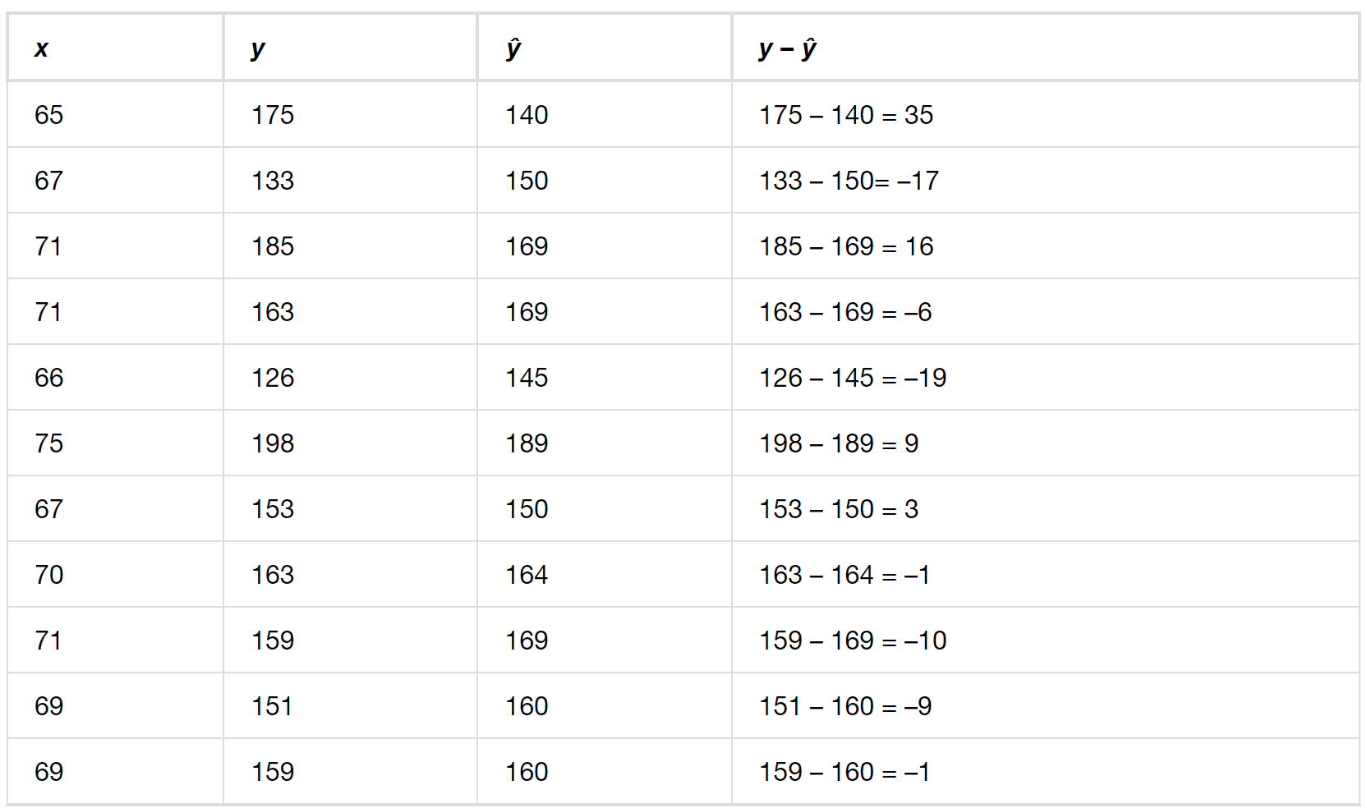
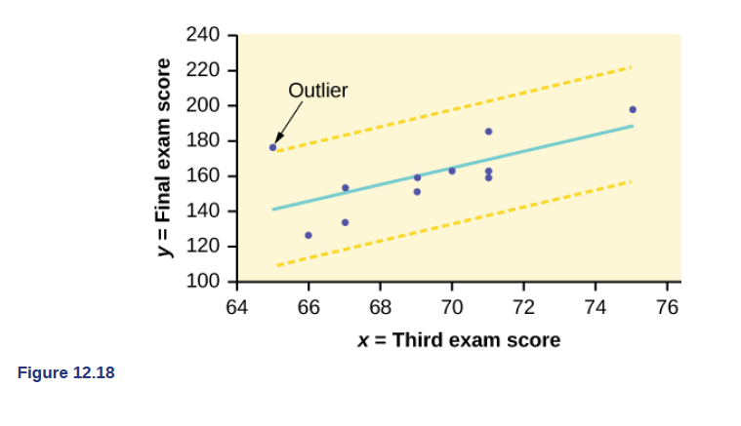

Example A random sample of 11 statistics students produced the following data, where x is the third exam score out of 80, and y is the final exam score out of 200. Remove any outliers, then compute the regression equation again.

Example The Consumer Price Index (CPI) measures the average change over time in the prices paid by urban consumers for consumer goods and services. The CPI affects nearly all Americans because of the many ways it is used. One of its biggest uses is as a measure of inflation. By providing information about price changes in the Nation's economy to government, business, and labor, the CPI helps them to make economic decisions. The President, Congress, and the Federal Reserve Board use the CPI's trends to formulate monetary and fiscal policies. In the following table, x is the year and y is the CPI. Refer to the Excel workbook.
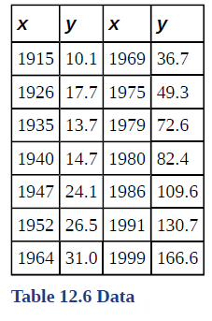
a. Draw a scatterplot of the data.
b. Calculate the least squares line. Write the equation in the form ŷ = a + bx.

c. Draw the line on the scatterplot.
d. Find the correlation coefficient. Is it significant?

e. What is the average CPI for the year 1990?

