Exam 3 Review Assignment
Study Guide – You will want to practice these for the exam from the OpenStax text:
- From Chapter 8
  - Practice: 6-22, 43-58, 74-90
  - Homework: 95-113 odd, 117-123 odd, 131
- From Chapter 9
  - Practice: 1-31 odd, 35-40, 49-61 odd
  - Homework: 62, 66, 74-80 even, 84, 98-104 even, 108-116 even
- From Chapter 10
  - Practice: 1-15 odd, 31-35, 41-50, 63-72
  - Homework: 79, 81, 90, 94-102 even, 106-112 even, 115, 121, 123
- From Chapter 12
  - Practice: 1-14, 17-35, 51
  - Homework: 57, 59-61, 64-67, 69-76

Chapter 10
The mean speeds of fastball pitches from two different baseball pitchers are to be compared. A sample of 14 fastball pitches is measured from each pitcher. The populations have normal distributions. Scouters believe that Rodriguez pitches a speedier fastball.
Pitcher | Sample Mean Speed of Pitches (mph) | Population Standard Deviation
Wesley | 86 | 3
Rodriguez | 91 | 7

31. What is the random variable?

32. State the null and alternative hypotheses.

33. What is the test statistic?

34. What is the p-value?

35. At the 1% significance level, what is your conclusion?

A study was conducted to test the effectiveness of a juggling class. Before the class started, six subjects juggled as many balls as they could at once. After the class, the same six subjects juggled as many balls as they could. The differences in the number of balls are calculated. The differences have a normal distribution. Test at the 1% significance level.
68. State the null and alternative hypotheses.

69. What is the p-value?

71. Draw the graph of the p-value.

72. What conclusion can you draw about the juggling class?

81. Mean entry-level salaries for college graduates with mechanical engineering degrees and electrical engineering degrees are believed to be approximately the same. A recruiting office thinks that the mean mechanical engineering salary is actually lower than the mean electrical engineering salary. The recruiting office randomly surveys 50 entry level mechanical engineers and 60 entry level electrical engineers. Their mean salaries were $46,100 and $46,700, respectively. Their standard deviations were $3,450 and $4,210, respectively. Conduct a hypothesis test to determine if you agree that the mean entry-level mechanical engineering salary is lower than the mean entry-level electrical engineering salary.

96. Some manufacturers claim that non-hybrid sedan cars have a lower mean miles-per-gallon (mpg) than hybrid ones. Suppose that consumers test 21 hybrid sedans and get a mean of 31 mpg with a standard deviation of seven mpg. Thirty-one non-hybrid sedans get a mean of 22 mpg with a standard deviation of four mpg. Suppose that the population standard deviations are known to be six and three, respectively. Conduct a hypothesis test to evaluate the manufacturers claim.

100. We are interested in whether the proportions of conferred physical science degrees for people aged 21 to 24 are the same for White and Black people in the United States. The number of conferred degrees for White people in a given year is 4,930. Five hundred eighty were aged 21 to 24. The estimate for Black people is 330. Forty were aged 21 to 24. We will let people with conferred physical science degrees be our population.

106. Researchers conducted a study to find out if there is a difference in the use of eReaders by different age groups. Randomly selected participants were divided into two age groups. In the 16- to 29-year-old group, 7% of the 628 surveyed use eReaders, while 11% of the 2,309 participants 30 years old and older use eReaders.

121. A local cancer support group believes that the estimate for new female breast cancer cases in the south is higher in Year 2 than in Year 1. The group compared the estimates of new female breast cancer cases by southern state in Year 1 and in Year 2. See the Excel file for the table.

Chapter 12
A specialty cleaning company charges an equipment fee and an hourly labor fee. A linear equation that expresses the total amount of the fee the company charges for each session is y = 50 + 100x.
10. What are the independent and dependent variables?

11. What is the y-intercept and what is the slope? Interpret them using complete sentences.

17. Does the scatter plot appear linear? Strong or weak? Positive or negative?
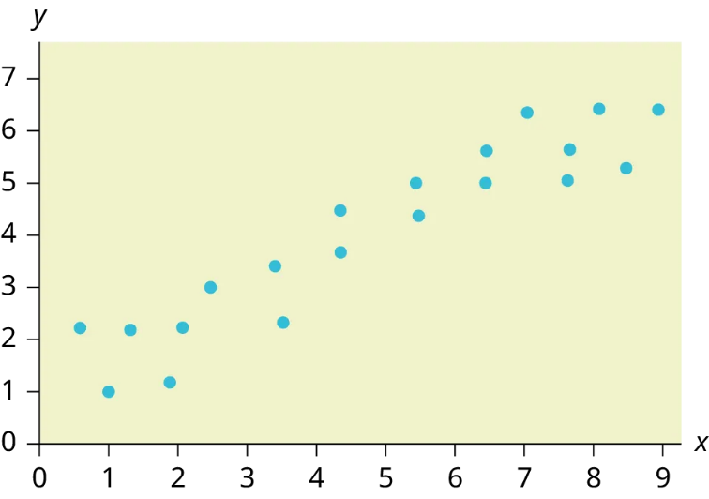
An electronics retailer used regression to find a simple model to predict sales growth in the first quarter of the new year (January through March). The model is good for 90 days, where x is the day. The model can be written as follows:
ŷ = 101.32 + 2.48x where ŷ is in thousands of dollars.
31. What would you predict the sales to be on day 60?

59. The Gross Domestic Product Purchasing Power Parity is an indication of a country’s currency value compared to another country. The table in Excel shows the GDP PPP of Cuba as compared to US dollars. Construct a scatter plot of the data.

64. What is the process through which we can calculate a line that goes through a scatter plot with a linear pattern?

65. Explain what it means when a correlation has an $r^{2}$ of 0.72.

66. Can a coefficient of determination be negative? Why or why not?

67. Recently, the annual number of driver deaths per 100,000 for the selected age groups was listed in the table found in Excel.
- For each age group, pick the midpoint of the interval for the x value. (For the 75+ group, use 80.)
- Using “ages” as the independent variable and “Number of driver deaths per 100,000” as the dependent variable, make a scatter plot of the data.
- Calculate the least squares (best–fit) line. Put the equation in the form of: ŷ = a + bx

- Find the correlation coefficient. Is it significant?

- Predict the number of deaths for ages 40 and 60.

- Based on the given data, is there a linear relationship between age of a driver and driver fatality rate?

- What is the slope of the least squares (best-fit) line? Interpret the slope.

70. The table gives the gold medal times for every other Summer Olympics for the women’s 100-meter freestyle (swimming).
- Decide which variable should be the independent variable and which should be the dependent variable.

- Draw a scatter plot of the data.
- Does it appear from inspection that there is a relationship between the variables? Why or why not?

- Calculate the least squares line. Put the equation in the form of: ŷ = a + bx.

- Find the correlation coefficient. Is the decrease in times significant?

- Find the estimated gold medal time for 1932. Find the estimated time for 1984.

- Why are the answers from part f different from the chart values?

73. Ornithologists, scientists who study birds, tag sparrow hawks in 13 different colonies to study their population. They gather data for the percent of new sparrow hawks in each colony and the percent of those that have returned from migration.
Percent return:74; 66; 81; 52; 73; 62; 52; 45; 62; 46; 60; 46; 38
Percent new:5; 6; 8; 11; 12; 15; 16; 17; 18; 18; 19; 20; 20
- Enter the data into your calculator and make a scatter plot.
- Use your calculator’s regression function to find the equation of the least-squares regression line. Add this to your scatter plot from part a.

- Explain in words what the slope and y-intercept of the regression line tell us.

- How well does the regression line fit the data? Explain your response.

- Which point has the largest residual? Explain what the residual means in context. Is this point an outlier? An influential point? Explain.

- An ecologist wants to predict how many birds will join another colony of sparrow hawks to which 70% of the adults from the previous year have returned. What is the prediction?

